

SANJOGA
(A Center of Excellence in Entrepreneurship)

Annual Report
2022-23

At/Po- Kantabanji
Dist- Bolangir, Odisha
Pin- 767039 (India)
Tel: 9437264453
Fax: +91-6657-221695
Email: SnJ_KBJ@REDIFFMAILCOM /entreprise98@gmail.com

CONTENTS
- From the MEMBER SECRETARY DESK
- THE GENESIS
- VISION AND MISSION
4.0 GEOGRAPHICAL COVERAGE
5.0 TARGET GROUPS
6.0 GOVERNANCE AND WORK ORGANIZATION
7.0 SANJOGA IN ACTION: OVERALL ISSUES ADDRESSED
8.0 DISTRICT INTERVENTION AND ACHIVEMENTS
8.1 FARMER PRODUCER COMPANY
8.2 WOMEN EMPOWERMENT
8.2.1 PROMOTION & LINKAGES OF WSHG’s OF MIGRANTS LABOUERER IN 20 GPS of KHAPRAKHOL& BELPADA BLOCK IN BOLANGIR DISTRICT-
8.2.2 GRASSROOT LEVEL TRAINING PROGRAMME ON WSHG MANAGEMENT
8.2.3 DIGITISATION OF WSHGS IN BOLANGIR DISTRICT
8.2.4 LIVEHOOD ENTREPRISE DEVELOPMENT PROGRAMMES (LEDP)
8.2.5 MICRO ENTREPRISE DEVELOPMENT PROGRAMMEON TERACOTTA PRODUCTION & MARKETING
8.3 INTEGRATED TRIBAL LIVEHOOD PROGRAMME (WADI) IN BELPADA BLOCK
8.4 training under voluntArY certification scheme for medeicinal Plant Produce (VCSMPP)
8.5 CYCLE RALLY with lights Campaign
8.6 URJAMITRA-- youth workshop ON WATER SOLAR PUMPS
8.7 IDENTITY CARDS TO ARTISANS
9.0. STAFFS ASSOCIATED WITH US
10.0 OUR SUPPOTERS AND COLLABoRATORS
11.0 VISITOR DURING YEAR 2022-23
12.0 Staffs participation IN TRAININGS
13.0. WHAT NEXT
14.0 EXECUTIVE COMMITTEE MEMBERS

From The Member Secretary Desk

New Year Greetings for Year 2022-23.

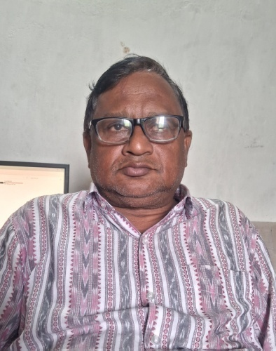
SANJOGA put one step forward of its life span 2022-2323 a year of up & down. The small team member’s support & their full cooperation in decision making, community mobilization, planning & execution of the targeted interventions helped SANJOGA to reach at its mission. During the year the decisions taken to involve more in strengthening community organizations, starting community enterprises, enhancing capacity of community ,benefitting poorest section of the society and reducing dependency of external support and starting new business models in the area is really helped us to step ahead. The financial support of National Bank for agriculture & Rural Development (NABARD), the switch on foundation (Kolkata), Block development office, Belpada is real praise worthy, without which more cannot be thought up. The marketing, product development, technology tie up, skill up gradation and other hand holding support provided to WSHGs, Udyan Vikas Sammittee(UVS), Farmers federation, FPOs and entrepreneur’s cooperation is no doubt a step forward towards creating a sustainable live hood services in a backward economy.

Further we are thankful to agencies extended support for training & individuals for sharing their experiences with us and among them NABARD, Switch on foundation, Indian chamber of commerce(Bhubaneswar),MEME-DFO(Cuttack),Quality council of India(New Delhi),regulated Market committee, Kantabanji are praise worthy.

We are thankful to our support agencies, collaborators to fulfill the objectives into real action and thank full to functionaries of state, central government agencies, financial institutions those extended heartfelt cooperation and beneficiaries/ well wishers for their service and contribution.

Jay Bharat.

With thanks

Place: - Kantabanji Kamalesh kumar Mohanty Date; - 30.07.2023 Member Secretary

2.0 THE GENESIS
“SANJOGA” is a not- for-profit development organization having registered office in Bolangir district started functioning from 1st January 1998. It functions as an autonomous institution with a management consisting of seven members with wide work experience in development sector. It got registered under the Society Registration Act. XII of 1860 in year 1999 having No. 20693/29 of 1999- 2000 at IGR Cuttack dated 17.06.1999 with the philosophy that “resource can be optimally utilized by target groups, by a people’s organization/intermediary groups through a process of capacity building , networking , micro level action research and collective marketing which ultimately increase the capacity for self reliance”. Further it is registered under FCR Act 1976 bearing No 104840051, date 14.12.2001, IT Act 1962 No. AABAS509CE20166 date on 24th September 2021. Also registered under section 80G dated 15.03.2022 and CSR 1 registration no CSR00046736.
3.0 VISION & MISSON
The organization “SANJOG “is built upon and started with the following broad based vision and mission:
- VISION
Promoting a just and equitable society with an integrated approach to help the marginalized sections of the society in mobilizing for self sustaining development organization and build up an institutional base for capacity building of intermediary agencies through micro level action, research, training, networking, documentation and consultancy.
- MISSION
- Sustainable livelihood promotion of rural poor specially women, SC/ ST communities and economically weaker section by organizing self sustained people organization and micro enterprise by utilization of existing skill and effective utilization of credit and resources.
- Enhancement of the technical and managerial skill of artisans/ Producers / NGOs / Farmers /entrepreneurs through organizing capacity building / training programme / workshops / seminars and other form of action programme on experimental basis .
- Increase the access of producers /artisans/ intermediary groups to financial institution and the other source of credit .Conduct participatory study, research and provide a forum for micro entrepreneurs , promote appropriate network among intermediately organization , create lobby and advocacy on their issues .
- Goal:- Building a just equitable and Entrepreneurial society

4.0 Geographical Coverage
The intervention areas cover primarily to two backward districts of Odisha state, ie; Bolangir and Kalahandi. The operational area in Bolangir district covers six blocks, 96 GPs and 499 villages. Similarly Kalahandi district covers one block, 9 Panchayats and 32 Villages. The total operational area is populated with 39% tribal and dalits population. The total work is managed by head office located at Kantabanji and with support of two local administrative offices.
Table-1
State | District | Block | G.P | No. of Villages
 | Bolangir | Bangamunda | 23 | 94
 | Bolangir | Belpada | 20 | 93
 | Bolangir | Turekela | 15 | 62
 | Bolangir | Khaprakhol | 7 | 14
 | Bolangir | Muribahal | 18 | 162
 | Bolangir | Titilagarh | 13 | 74
 | Kalahandi | M.Rampur | 9 | 32
 |  | Total | 104 | 531

Administrative Office:
Bolangir | Ward No- 12, Birna Road,Kantabanji, Po. – Kantabanji, Dist.- Bolangir,Odisha – 767039  Email – snj_kbj@rediffmail.com, entreprise98@gmail.com  (M) 9437264453
Bolangir | At-Beheramunda,Po- Borbahal, Via- Jogimunda,Dist:- Bolangir,Odisha
Kalahandi | At/Po.- Mohangiri (Shantipara),Via.- M. Rampur, Dist.- Kalahandi, Odisha-766012,(M) 8018090887, 8895153352

5.0 Target coverage:
Sanjoga is working with 45,400 beneficiaries. The targeted beneficiaries come under the categories of tribal, dalit , other ackward, general communities from BPL families, women, small and marginal farmers, migrant workers, artisans/ producers etc.

6.0 Governance and work organization:

The organization adopts a complete democratic process followed by bottom up decision making process. The general body consists of 21 members with appropriate representation of women, tribal and dalit communities. The general body meets at least once a year to transact its mandated business. The governing body constitutes of 7 members who are being elected from general body, maintaining by proportionate representation from women and tribal community. The administrative and work organization vests with member secretary as chief coordinator of the organization. The coordinator and field in charge are guided by respective project heads in consultation with chief functionary. Different sub committees are constituted to review the planning, progress, finance and evaluation etc

Organization Structure

GENERAL BODY
( 21 MEMBERS)

EXCUTIVE COMMITTEE

(7 Members)

MEMBER SECRETARY CUM
CHIEF OPERATING OFFICER

ACCOUNTS &ADM
ADMINSTRATION
Kalahandi
FIELD UNIT -I
BOLANGIR
FIELD UNIT-I
ACCOUNTANT (ONE)
FIELD coordinator

Project coordinators(WADI/ESHAKTI )

OFFICE ASST. (One)

Block Coordinators
FIELD ASSISTANTS (two)

(3 Nos.)

field ASSOCIATES

VDC

SHG

7.0 SANJOGA in Action: Overall Issues addressed:
The western Odisha especially Bolangir & Kalahandi districts are hemmed with problems of household level food insecurity, interstate migration, chronic poverty, adverse effects of climate change, indebtedness, loss of forest resource and biodiversity. Keeping in view the urgent need, the following issues are beings addressed with community initiative.
- Climate change:
The rural and tribal communities are major inhabitants of the districts of western Odisha, are frequently experiencing the adverse effects of climate change which is manifested in the form of erratic rainfall, drought, high temperature, pest infection, crop loss, water scarcity etc. which has diverse effect on livelihoods of the community as they depend on forest and agriculture produce as main stay of their livelihoods. The communities have taken initiatives to final a way out by different ways and means, such as:-
- Low Crop production:
Agriculture, horticulture and allied activities are the mainstay of livelihoods. Regular Crop failure and low productivity is being experienced. The traditional skill and knowledge of farmers, use of ordinary seed, irregular rainfall, drought like situation, soil degradation, poor farm mechanization, distress sale of lab our and produce is a major cause for low production.
- Migration:
In the context of drought, non availability of employment, alienation of productive assets, migration of small and middle peasants, tribal, dalits and landless laborers migrate to urban areas and outside state in search of employment opportunities leading to exploitation and poor quality of life. Both “Pulling” and “Pushing” factors found responsible for distress interstate and intra- state migration. The pushing factors found dominating and compelling result ultimately in destroying.
Regular by crop loss on the one side and lack of employment on the other, the youths from small farmers and agriculture Labour driven by hungry and penury to far off place like Hyderabad, Raipur, Nagpur, Mumbai. Life in a drought year became so unbearable in their own villages even the horror stories in those unfriendly climate recounted by previous migrants fails deter them from leaving their home and health for distant place in search of live-hood. 70% of youth force migrates in search of employment.
- Drought:
Erratic rain fall through a major contributing factor to the problem of recurring drought and distress in the area still does not adequately explain the extremely poverty in which the vast majority of people are living. The people sale their produce at a throw away price. The distress sale of NTFP and Agri produces compel the farmers and poor people to close down their business and migrate to other livelihood.

- Gender and women issues.
The women play an active role in the household economy through participation in agriculture and wage earning. They enjoy a lower social status. But the wages during the agriculture season varies for women ranges from 150 to200/- and male Rs. 200/ to 250/-. Alcoholism among men leads to intra
Household’s feuds leading to violence against women. Literary percent in the target village is 27% in cases of women. Despite of all sustained effort have led to women rising against injustice heaped in them and their instances when have brought out rallies against alcohol. The consumption of liquor reduces the purchasing power of the family and many family resorts to consumption credit. The women do not have participation in public sphere, especially in public offices or in traditional institutions. The women in panchayatiraj institution are dominated by the males and are not aware on their responsibilities. This puts women in a much disadvantages position. Especially in the enact of marital or any familiar disputes.
Trafficking of women and children primarily found in Kantabanji areas since many years back. Basically women are taken to Lucknow, Delhi, Vanaras, Jhansi, Bombay, Nagpur and other places of Uttarpradesh, Madhya Pradesh states for marriage, forced labour and prostitution. This is due to poverty, illiteracy and ignorance.

8.0 District interventions and achievements:
8.1 Farmers Producer Company:-
ONION, vegetables, cotton and paddy is cultivated widely in Bangomunda, Titilagarh, Muribahal, & Turekela block of Bolangir district. Each year farmer produces approximately 15000 tons, value approximately above 3 Crore Rupees. More than 15000 farmers cultivate onion, vegetables, cotton as cash crop each year using local available inputs, skill, technology & traditional practices.
The ignorance in land treatment measures, uses of local available seed, timely credit need, water management, harvest & storing technologies, lack of value addition, distress sale etc. add to woes of farmers in low productivity. During harvest the farmer’s lacks skill on post harvest technologies and inadequate infrastructure facilities for drying and storing. The non remunerative price is also
a factor for low productivity. Once the harvest is over, the farmers sold out his raw produces and repay the debt of sahukars. The initiative of state government in supplying seed in delay, farming
Practices, pre and post harvest technologies, proper training and guidance is not adequate. Considering these factors, the women onion growers are federated and registered into a producer company called “Poschima Odisha Women Farmers Producer Company Ltd” has been registered with support of NABARD to take up vegetables, onion, cotton cultivation & marketing programme with initial membership of 413 women farmers. During the year the company has done a business turnover of 7.39lac of onion and vegetable seeds. Different training programmes are being organized for benefit of the producer members with support of NABARD during the year.

8.2 Women Empowerment:--
Empowerment of women strata is crucial to the sphere of development process at all level as the women have vibrant participation in the socio-economic development process. The rural women are coming in organized way through SHGs/WSHG in order to address their issues/ problems and meaningful delivery of Services. SANJOGA is playing a vital role in formation and strengthening of SHGs. The SHGs are the instrumental in the process of financial inclusion, covering and mobilizing government development programmes.
8.2.1 Promotion and linkages of SHGs of migrant’s laborers 20 Gps of Khaprakhol and Belpada Block Bolangir district-
The Migrant women SHG programme started through Sanjoga in three Gps of each block Belpada and Khaprakhol Block with following broad objectives. The project started from the period 8th August 2017 and completed on 7th August 2021.
- To provide access to regular banking services to the poor household in rural area by formation and nurturing SHGs of migrant women.
- To cover other development programmes aimed at poor women/households through these groups.
- To promote and support livelihood development programmes for the poor through SHGs.
- To socio-economically empower the poor women through group promotion, capacity building, credit linkage and helping in executing business activities. As on 31st March 2023, details of achievements are given in the following table: -

Table:-1
Sl No | District | Block | No of Wshg formed | Number of members | Groups Credit Linked | Amount of Credit (Lac | Amount of Credit (Cummu)lac | Banks
1 | Balangir | Belpada | 71 | 781 | 9 | 11.70 | 11.70 | Utkal Grameen Bank
1 | Balangir | Khaprakhol | 220 | 2244 | 62 | 43.50 | 76.50 | Utkal Gramin Bank & State Bank Of India
1 | Balangir |  | 291(72.75%) | 3025 | 71(17.75%) | 55.20 | 88.20
During the year Sanjoga has put its efforts to strengthen the leadership, managerial capacity and skill through organizing a number of refresher training programmes at village level. Resource person were invited from Banks, NGO & outside. The details are given below;-
The credit linked groups are being provided handholding support, skill training, linking with schemes and engaged in different micro income generating activities.
8.2.2. Grass root Training programmes on WSHG management
To aware and educate shg members on various aspect of SHG management and their active participation in live hood promotion programme , Sanjoga in collaboration with NABARD conducted a grassroots level trainings at Hial in Tureikela block. The duration of training was one day. Experts from Local Bank, OLM, ICDS and Nabard were participated as Resource persons and shared their thoughts and long experiences. The branch manager Union Bank, Kantabanji inaugurated the programme by lightening the candle at Hial and branch manager, UGB,Bankel at Bankel. Many places the participants were practiced the exercises given to them for better learning. The group members were motivated on how to start new group enterprises through group discussions. The details trainings conducted as per table given below;-
Table-2
District | Block | Date | Venue | Participants
Bolangir | Tureikela | 22.07.2022 | Rajiv Bhawan,Hial | 65
Bolangir | Muribahal | 24.08.2022 | Bankel | 118

8.2.3 Digitization of WSHGs in Bolangir District

Digitization of SHGs keeping in view the Govt. of India's mission to "transform India into digitally empowered society and knowledge economy", NABARD has launched a project for digitization of all SHGs in the country.
The broader aim of the programme is to support the flagship programmes of GoI by –
- Integrating SHG members with the national Financial Inclusion agenda
- Improving the quality of interface between SHG members and banks for efficient and hassle
Free delivery of banking services Facilitate convergence of delivery system with SHGs using Aadhaar linked identity
. Benefits of digitization:
- Main-streaming of SHG members with national Financial Inclusion agenda to access a wider range of financial services;
- Digitization of SHG accounts will increase bankers' comfort in credit appraisal and disbursal
- Automatic and accurate Rating of SHGs will be available, online for Banks;
- Mapping of persons not covered under Aadhaar and bringing them under Aadhaar platform
- Ease of transfer of social benefits and DBT through Aadhaar linked accounts and convergence with Governments other benefit schemes;
- A comprehensive information base and robust MIS can be developed on poor which may facilitate interventions/convergence of other programme for social and financial empowerment

Under this project Sanjog is assigned to digitize 4537 well function WSHGs in Belpada,Bangomunda,Muribahal, Tureikela & Titilagarh, block of Bolangir district. As a part of it 150 animators are identified and provided necessary skill to complete group wise meeting, collect data and upload in ESHAKTI portal. Further animators are regularly organizing group level monthly meetings, assisting them in record keeping and helping in application collection, credit linkages and recovery with banks with joint support of CRP/MBK and AWW. The project was implemented till the period ending on 30th September 2022.
Table-3
Sl | District | Block | No of animators | No of Wshgs covered under EShakti
1 | Bolangir | Belpada | 34 | 1030
2 |  | Bangomunda | 37 | 1124
3 |  | Muribahal | 36 | 1115
4 |  | Tureikela | 26 | 753
5 |  | Titilagarh | 17 | 515
 |  |  | 150 | 4537
 |  | Total |  | 4537

8.2.4 Live hood enterprise Development Programmed (LEDP)
A felt need to evolve a holistic intervention mechanism has emerged to take care of the entire ecosystem required for live hood promotion of SHG members. To enable the shg members to take advantage of scale of economics, it is essential to aggregate the demand for raw materials as well as produce through appropriate market intervention. This facilitation may be intermediated with collectives of SHGs in a cluster of continuous villages. It is that they could eventually be nurtured into producer group of farm and nonfarm activities over a period of time. Keeping view the relevance of sustainable live hood development needs of shg members the live hood enterprise development programme was organized in different trades as per requirement of matured groups as per details given below. The members from the shgs were identified in a cluster, motivated and imparted skill training and motivated to get in to business activities.. Following follow up activities is taken up for benefit of the trained groups:-
- Bankable Business Plans are prepared and helping the groups to submit with banks.
- Identify potential traders/institutional buyer to assist in marketing
- Identify machine supplier and raw material source and packaging etc
- Convergence with Odisha live hood mission.
Soon after completion of the training the Covid-19 started and the trained members remained salient over the years. Recently the members formed a producer group, installed a machine for badi making purpose and started production and marketing at local level.. Three WSHGs were also availed bank loans in this regard. The live hood mission, Tureikela also supported this mission under convergence mode.
The docra unit members at Mohangiri also started productions and selling through local festivals and melas.
8.2.5 Micro Enterprise Development Programme (MEDP) on Teracotta production & marketing
Basically the micro enterprise development programme envisages providing skill and capacity on artistic method to pottery works, processing of clay, production of terracotta items and focusing on value addition and optimum utilization. The inputs required for skill training on raw material collection, processing facility, designing and packaging of finished goods and storage facility.
Further it aims at adopting on artistic method of pottory works including terracotta production by imparting training and appropriate skill to the women engaged in pottery works. Presently the production in traditional method and traditional items facing problem in marketing due to less demand of buyers. Hence change in design, colour and packaging is highly essential. The production is now not in organized way. Considering this with support of NABARD we have organized a 12 days training programme involving 30 women artisans. They were trained under the guidance of master crafts person. Both managerial and technical skill inputs were provided to them .It was conducted from 28th March 2023 to 8th April 2023 at Bangomunda. The programme was inaugurated by DDM,Nabard,Bolangir in presence of Local bank staff and Block project

Coordinator, OLM Bangomunda Block. After completion of training a producer group named Dakhya Prajapati Producer Group of trained women was formed and open a bank account in Utkal Grameen Bank, Bangomuunda Branch. Now they have planned for production and market it.

8 .3 INTEGRATED TRIBAL LIVEHOOD PROGRAMME (WADI) IN BELPADA BLOCK:-

Sustainable live hood enhancement of 400 tribal families in five villages of Ghagurli and five villages of Beheramunda Gram panchayat of Belpada block in Bolangir district through Orchard development (1st year-100,2nd year-269 , income generation for landless (31 beekeeping) was planned under the WADI project. The geographical location, climate, soil condition of the area is suitable for mango, cashew like horticulture and pulses, vegetable, tamato, oil seed like cash crops. The tribes belongs to Sabar, Munda, Binjhal, Kandha, Gond, Dal sub caste, are well acquainted with forest spices/ horticulture crops and linked with their livelihood over a period of years with support of horticulture, Agriculture, animal husbandry, banks, panchayatiraj departments . Further the area comes under a dry region, sandy loom and migration prone. Drought is a regular phenomenon in every alternate year.
The integrated orchard development for tribal communities covering 1 acres of land consisting 15 mango plants in 0.3 acres, 57 cashew plants in 0.7 acres , 100 forest plants in boundary. In short run the tribal will get benefits by introducing intercropping (Pulses, vegetables) and associating them in labour incentive works in the project and later income from sale of fruits/ vegetables and other inter crops collected from orchard on regular basis and its further processing and value addition in long run.
It further aims at integrated development of tribal community focusing on land, water and orchard management aspect through proper soil conservation measures, water resource development, establishment of horticulture orchard, intercropping practices reviling in 1 acre land of a tribal farmer field effectively. Regular capacity building, training, demonstration, exposure visit has increased the tribal family’s participation and generating income from horticulture & inter crops. Incase landless the support for beekeeping activities would help them to stand with their own feet within a short period. The health care and women development activities planned will help them to motivate and enhance their capacity, income and collective strength to continue in long run. The farmers’ Producer company build up will manage the whole affairs of project continuity in long run. The project stepped into 5thyear (2023-2024) of implementation. The details of salient achievements;-

Under the projects till the year 2022-23 are given below Table:-3 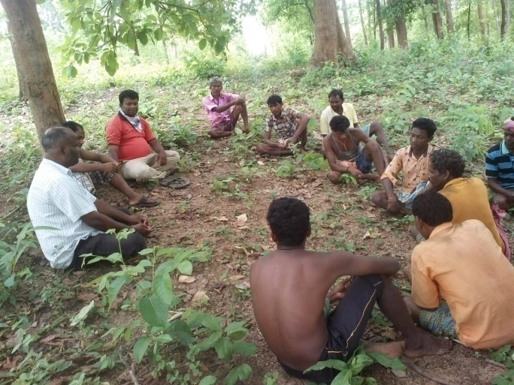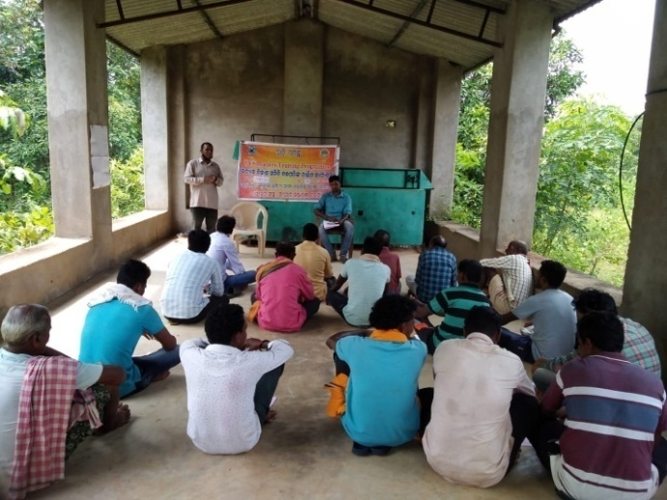

(UVS Leaders Training programme at Pandakimal & Ghaghra village)

slno | Programmes | Villages | No of UVS /units | Area covered(ac)/units | No Of Farmers
1 | Formation of Udyan Vikas sammittee (UVS) | Beheramunda,Kadali,Chikili,Pandakimal,Ghagara,Dhungiamunda | 20 | 369 | 394
 | Federation of UVS( Regional Udyan Vikash Farmers Federation) | Beheramunda,Kadali,Chikili,Pandakimal,Ghagara,Dhungiamunda,Beribera,Mundagaon,Doramunda, Dumerbahal | one | - | -
2 | Pit Digging & Horticultural Plantation( mango, cashew) | Kadali,Ghagara,Chikili,Pandakimal,Beheramunda  ,Dhungiamunda,Doramunda,Beribera,Ghagara,Mundagaon | 20 | 369 | 394
2 | Intercropping(Tamato,vegetables,chilli,nutrition kit, water melon ) | Beribera,Doramunda,Mundagaon, Beheramunda,Kadali,Chikili,Pandakimal,Ghagara,Dhungiamunda | 20 | 347ac | 374
3 | Soil conservation works(SCW)
3 | Half-moon Structure | Beribera,Doramunda,Mundagaon, Beheramunda,Kadali,Chikili,Pandakimal,Ghagara,Dhungiamunda | 20 | 369ac | 394
4 | Water Resource Development(WRD)
4 | Bore well | Doramunda,Beribera | 3 | 29ac | 33
4 | Bore well(solar) | Doramunda,Beheramunda,Dhungiamunda,Ghagara | 6 | 95 | 95
4 | Pumpset | Doramunda,Beheramunda,Dhungiamunda,Ghagara,kadali,pandakimal | 15 | 65 | 136
4 | Drip & sprinkler pipes sets | Doramunda,Beheramunda,Dhungiamunda,Ghagara,kadali,pandakimal | 10 | - | 35
4 | Water Storage Tank(cement) | Beribera,Doramunda,Mundagaon, Beheramunda,Kadali,Chikili,Pandakimal,Ghagara,Dhungiamunda | 43 | 43 nos tank | 43
4 | Water box | Beheramunda,Kadali,Ghagara,Pandakimal,dhungiamunda,Dumerbahal | 2000 | 80ac | 95
4 | WHS | Beheramunda,Kadali,Ghagara,Pandakimal,dhungiamunda,Dumerbahal | 13 | 25 | 94
4 | Earthen storage Tank | Beheramunda,Kadali,Ghagara,Pandakimal,dhungiamunda,Dumerbahal | 16 | 63 | 205
4 | Vermipits | Beheramunda,Kadali,Ghagara,Pandakimal,dhungiamunda,Dumerbahal,Beribera | 394 | - | 394
4 | Pump set with Pipes | Beheramunda, Ghagara,kadali,Dhungiamunda | 14 | 14 pumps | 136
5 | Landless families support programmes | Beebox with beehives | Kadali,Beribera,Dhungiamunda,Beheramunda,Doramunda | 24 families | 165
6 | WADI PLUS ACTIVITIES | Programmes details | Venue | No of units/programmes | Participants
 | 28.10.2022 | UVS leaders training on Vermipit construction | Doramunda | 1camps | 38
 | 18.09.2022 | Capacity building and skill Development of wadi farmers /staffs | KVK, Bolangir | 1camps | 34
 | 31.10.2022 | UVS leaders -secretary and president training | Ghagara | 1 nos | 48
 | 03.02.2023 | Wadi farmers sensitization programme | Dumerbahal | 1nos | 26
 | 18.09.2022 | Training of PIA staff | Kantabanji,Beheramundaa | 2 nos | 16
 | 4.02.2023to5.02.2023 | Exposure of landless farmers to Other WADI fields | Sarvoday sammittee,Koraput | 1nos | 14
 | 07.02.2023 | UVs leaders training programme | Gp office,Dhungiamunda | 1nos | 38
7 | IGA for landless |  |  | -
7 | 23.10.2022 | Formation of landless group and beekeeping training | Beheramunda | 1nos | 14
8 | Women development |  |  | -
8 | 13.04.2022 | Streamlining WSHG in Wadi area | Beheramunda(Banjipada | 1nos - | 12
9 | Health Programmes |  |  | 1 nos | 45
 | 24.04.2022 | Open defecation free campaign | Ghagara | 1camp | 43
 | 24.04.2022 | Open defecation free campaign | Dhungiamunda | 1 camp | 53
 | 24.04.2022 | Open defecation free campaign | Doramunda | 1camp | 42
 | 01.08.2022 | Health Camp | Dhungiamunda | 1camp | 61
 | 06.08.2022 | Open defecation free campaign | Dumerbahal | 1camp | 48
 | 10.03.2023 | Training on mother & child health | Dumerbahal | 1camp | 38

8.4 TRAINING UNDER VOLUNTARY CERTIFICATION SCHEME FOR MEDICINAL PLANT PRODUCE (VCSMPP)
One day training on VOLUNTARY CERTIFICATION SCHEME FOR MEDICINAL PLANT PRODUCERs (VCSMPP) was organized at Kantabanji with technical and financial support of Quality council of India, Newdelhi Ministry of Commerce, Newdelhi on 22.12.2022 The event started after lightening the candle by local forest range Officer, Kantabanji. During the training around fifty farmers were participated those engaged in medicinal plants cultivation. The technical experts Dr J.Jangeiya,Dr Subash Chandra Swain and Dr S.S korenga were participated and shared their rich experience on medicinal plant cultivation package of practices with farmers. They also discussed schemes of national medicinal plant Board. The participants were appreciated the contents and took decision to take it in large way in the area.
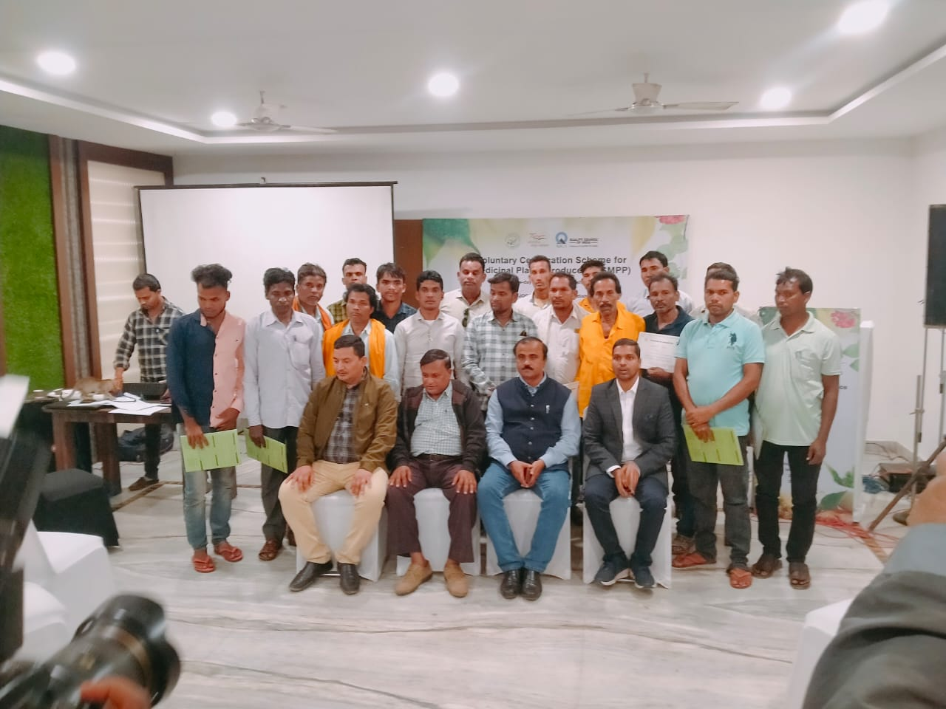
(Voluntary Certification Scheme for one day on Medicinal Plant Produce Training by Quality Council of India at, Alishan Resort Palace, Kantabanji)
8 .5 CELEBERATION OF CYCLE RALLY WITH LIGHTS CAMPAIGN :
To save mother earth, a cycle rally campaign was organized at Dhungiamunda village on 22nd October 2022. 30 participants from nearby villages joined in the campaign and marched from Dhungiamunda to Beheramunda village with decorative lights, banner and speaker with their hands. Etc. The programme was supported by Switch on foundation, kolkatta. The objective of the campaign is to create awareness among community to save earth from various manmade and natural disasters and create pro environment friendly activities.

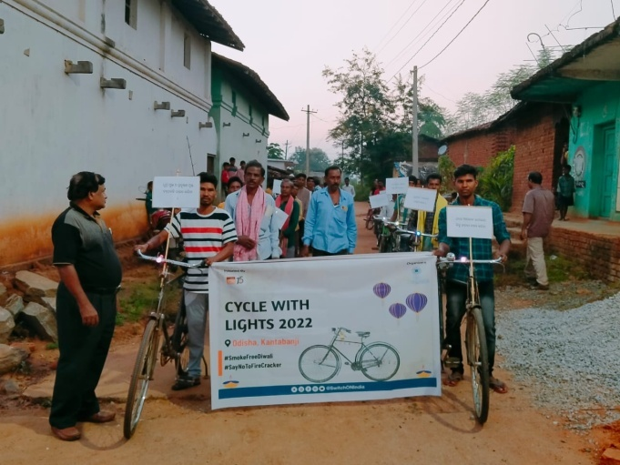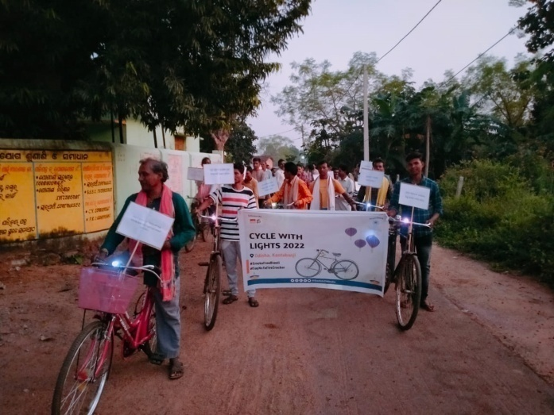
(Celebration of Cycle with Lights in Dhungiamunda Gp- Beheramunda Belpada)

7.6. Urjamitra - Youth workshop on solar water pumps
As we all know, non-renewable energy sources are dwindling soon and renewable energy will become our only sole source by means of life and livelihood. For that possibility, we have planned to involve ourselves in many eco-friendly activities mainly based on solar, and in this regard, we are organizing a 3 hours youth workshop to explain how solar water pumps are becoming corresponding to non-conventional energy and has been able to bring a revolutionary change in the agriculture sector, operation – maintenance - troubleshooting of solar water pump and above all to inspire potential talent through awareness to maximize the scope of securing their livelihood as solar entrepreneurs and skilled solar technicians in the future. The entire training will be conducted by the highly experienced and skilled solar faculty of our institute. Although students of any trade can attend the workshop yet the student of 2nd and final year from mechanical, electrical, electronics, fitter, welder, instrumentation, and civil trade are more desirable as targeted beneficiaries. The workshop will be held digitally (PPT and video), so a smart classroom (a classroom with a projector, projector screen, laptop, and microphone) will be very useful. We will provide student’s training handbook and certificate for all participants and also we will inform them about a digital learning portal (environ.switchon.org.in). A portal where students can access, study about solar basic and advanced courses, appear in the exam, and get a certificate absolutely free. The topic will be emphasized through the workshop are mentioned below -

Sl no | District | Block | Location | Date | No of Participants
1 | Bolangir | Tureikela | GOVT.ITI,Kantabanji | 21.12.2022 | 120
2 | BOLANGIR | Tureikela | MLA Womens Colleage,Kantabanji | 23.12.2022 | 50
3 | Bolangir | Belpada | Sri Sri Jagannathdev Colleage,Mandal | 06.02.2023 | 65
4 | Bolangir | Bangomunda | Panchayat Sammittee Degree  College, Bangomunds | 08.02.2023 | 45
- Basic introduction to solar
- Utility of solar water pump (SWP)
- Difference between SWP and diesel pump
- Components and application of SWP
- Operation and maintenance of SWP
- Disadvantages of SWP and its solution
- Troubleshooting
- Scope of livelihood and empowerment in the solar industry

- Information about government / CSR sponsored Youth Empowerment Programs on Solar

With aims to promote awareness building, enhancement of knowledge and skill on renewable sources of energy (especially solar) among the community people ,we in association with SWITCHON FOUNDATION ,Kolkata organized 4 batches of youth workshops on solar pump repairing during the financial year 2022-23 as per details given below:-

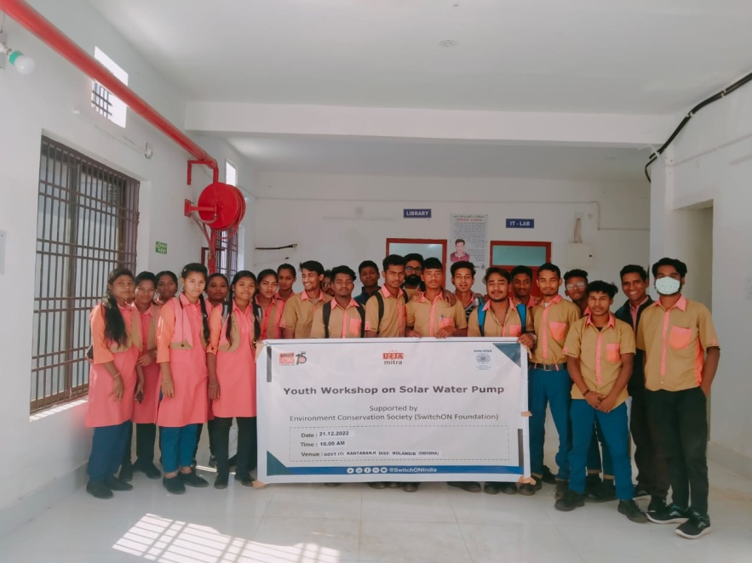

(Urjamitra Youth workshop solar Water Pump in GOVT ITI Kantabanji)

8.7 IDENTITY CARDS TO ARTISANS:

In association with Development commissioner (Handicrafts), Handicrafts service extension centre ,sambal pur 31 teracotta artisans were identified and issued with adhar linked electronic identity cards(PEHCHAN)
Of the craft persons of Bangomunda & Belapada block areas in Bolangir District.

9.0: | Staff Associated with us
Sl No | Name & Designation | Experience
1 | Kamalesh Kumar Mohanty  (Member Secretary cum Chief Executive officer) | 35 years of grass root experience in development field, Specialized in Skill training, rural enterprise promotion, business leadership and communication, entrepreneurship, marketing and livelihood programme. Working as a trainer in conducting EDP programme and trained from EDI as a trainer.
2 | Sushanta kumar Patro  ( Project Coordinator) till 30th March 2023 | 15 years experience on SHG promotion, micro finance programs, Grass root training, NTFP value added enterprises, rural marketing and Horticulture plantation, Bee keeping etc.
3 | Lalu Prasad Chandan  (Accountant) | 5 years work experience in NGO accounting, Tally-ERP 9.0 and office administration.
4 | ChandraBhanu Jena(field associate)9 30.09.2022) | Five years experience in Shg formation, management, documentation, digitization of Shgs, small business development in group and facilitator in wadi project implementation.
5 | Ratnakar Mohapatra(Block co- ordinator) | A graduate in commerce with 4 years’ work experience in WADI project implementation
6 | Pandav Swain( consultant) | A graduate in Agriculture and having 38 years of field experience in agriculture extension, social forestry ,organic farming and retired from agriculture department, Govt of Odisha
7 | Tularam Mallick | Five year experience in Social audit under MGNREGA Programme in Belpada Block
8 | Rajaram Sahu | Five year experience in Social audit under MGNREGA Programme in Agalpur Block
9 | Jagannath Deheria  (Volunteer) | A matriculate with 10 years work experience on community mobilization, conducting skill training and livelihood programme etc.
10 | Nilamber Das(field coordinator) | A graduate with 15 years experience in SHG formation, management and managing NTFP based community enterprises and natural resources management.
11 | Sourav Ranjan Dash(Horticulture officer) | Bsc in Horticulture with 2 years of field work experience in horticulture extension programme in Bolangir District.
12 | Jogendra Hans( field Supervisor) as on 30.03.2023 | A graduate in Science having one year work experience in Eshakti digitization works and supervision works.
13 | Pankaj Dip ( Field super visor) | A graduate with 13 years work experience in community organization building, organizing skill training, Lac cultivation, Micro credit, Beekeeping, Community based enterprises and natural resources management. Three years experience in Wadi project implementation in Tribal pockets of Bolangir District.
14 | Gouranga Bag( Field Super Visor) | A Matriculate e with 10 years work experience in Shg formation, documentation, organizing skill training, credit linkage and two years experience in wadi Project Implementation.
15 | Bibhisan Kuanar | A graduate with 3 years work experience in community organization building, organizing skill training, Beekeeping, community based enterprises and natural resources management. Three years experience in Wadi project implementation in Tribal pockets of Bolangir District

10.0 Our Supporters & Collaborators:-
We believe our partners are our strength. We raise funds through subscription of membership, Donation, Training Fees, Gifts, Consultancy, Grants, and Loans, sales, Service Charges collected from Individual, Institution, and Government & Non Government agencies. Among these following are noteworthy and always praise worthy.
National Bank for Agriculture & Rural Development (NABARD)  Nayapali Civic Centre, Bhubaneswar  www.nabard.org | The Environment conservation society,(switch on Foundation), Kolkatta, www.stichon.org
Block Development Office, Belpada , Bolangir | District Development Manager,Nabard,Bolangir

11. Visitors during year 2022-23

Mr. Laxman Soy , DDM,Nabard, Bolangir | Mr Victor Soreng, Block Development Officer,Belpada Block,Bolangir District
Mr O.P.Mund,FLCC Coordinator,SBI,Bolangir | Mr Jyoti Ranjan Nayak, Kendrapada
Seema Behera, JC,Eshakti Project,NABARD | Mr Subvjit Saha, Project Manager, Switchon Foundation, Kolkatta
Dr S.S.koranga, Consultant, Quality Council of India, Newdelhi | Mr Jangaiah, Manager,Quality Council Of India, Ministry of Commerce, Newdelhi
Dr Subash Chandra Swain,associate Professor,(Hort),OUAT,Bhubaneswar

12.0 Staffs participation in inside and OUTSIDE TRAININGS
Sl | Name of Staffs | desiGnation | Programme details | Duration | Host agency | Venue
1 | bInoy Kumar Mohanty | volunteer | Loan mela for Msme-easy credit flow | 19th Aug 2022 | cii,Bhubaneswar | hotel swosti premium
2 | BImalesh Mohanty | volunteer | Loan mela for Msme-easy credit flow | 19th Aug 2022 | cii,Bhubaneswar | hotel swosti premium
3 | KamalesH kumar Mohanty | Member secretary | TOT on urjamitra solar pump training | 20th Aug 2022 | Swithon foundation | Kantabanji
4 | Lalu prasad chandan | Adm. asst | TOT on urjamitra solar pump training | 20th Aug 2022 | Swithon foundation | Kantabanji
5 | Jogendra Hans | Block coordinator | TOT on urjamitra solar pump training | 20th Aug 2022 | Swithon foundation | Kantabanji
6 | Jyotshna mayee behera | office Asst. | TOT on urjamitra solar pump training | 20th Aug 2022 | Swithon foundation | Kantabanji
7 | Kamalesh kumar Mohanty | Member secretary | National seminar on marketing support to msmes | 25.11.2022 | Msme cuttack | Hotel swayam,Bolangir
8 | kamalesh kumar mohanty | Member secretary | Odisha food processing conclave | 16.12.2022 | Cii,Bhubaneswar | The HHI,bhubaneswar
9 | Binay kumar mohanty | volunteer | Odisha food processing conclave | 16.12.2022 | Cii,Bhubaneswar | The HHI,bhubaneswar
10 | Prafulla kumar Panda | consultant | Odisha food processing conclave | 16.12.2022 | Cii,Bhubaneswar | The HHI,bhubaneswar
11 | kamalesh kumar mohanty | Member secretary | E market place | 03.01.2023 | RMC,Kantabanji | Kantabanji
12 | kamalesh kumar mohanty | Member secretary | FPO conclave | 10.01.2023 | Nabard | Hotel padmaja premium,bhubaneswar

13.0 What Next
SANJOGA” on completion of its Twenty five years of life span has been working consistently towards one end poverty reduction, skill development & self employment leading to socio-economic upliftment of the community-in Kalahandi & Bolangir region in state of Odisha. The area is a backward one coming through irregular rainfall, drought in consecutive years, massive deforestation, large scale migration to boarder states, distress sale of agriculture & forest produces and ill health opened the eye to consider the severity and restore & rebuilding the livelihood processes by utilization of local resources, skill and human power. The challenges –unemployment, poverty, fair Price to producer, reducing distress migration, Conservation of biodiversity – is to mitigate by a model intervention through -micro enterprise promotion & skill training would replicate and bring a long-term change in the lives of poor in the region. The forward and backward linkages for those victimized would be given due importance with trust on farmer potentiality. The development of human resource by imparting technical skill training, self employment courses, literacy skill, enterprise education & creating scope for capital input to farmers definitely help the large volume of educated unemployed, adolescents, illiterate farmers in distress to contribute to the national income. The collective voices can achieve a lot, a way towards empowerment of the society, by formation & strengthen of self-help movement, building micro financing institution, farmer’s producer group in the Region. Health care aspects with thrust on women health, nutrition for children, malaria control would integrate with ongoing activities in coming days.
14. Executive Committee Members
Sl. | Name | Designation | Address | Qualification | Profession
1 | Mr Ashok Kumar Das | Chairman | Ashok Nagar,At/po-Kantabanji,Dist-Bolangir | B.A.LLB | Advocate
2 | Mr Pandav Swain | Vice Chairman | At-Durga Bazar,po-Dasapalla,dist-Nayagarh | Bsc (AG) | Social work
3 | Mr. K.K. Mohanty | Member Secretary | At/po-Kantabanji,Dist-Bolangir,Odisha | M.A(DRD) | Social Work
4 | Mr. Amarendra Ku Sethy | Joint Secretary | At-Gorubazar,Po-Bolangir,Dist-Bolangir | M.A,BEd,M Phil | Teaching
5 | Ms Jyosthnabala Tripathy | Treasurer | At-Bambilo,po-Basandara,Via-Biridi road,Dist-Jagatsingpur | BA(Hons) | Social work
6 | Mrs Rama Majhi | Member | At/po-Mohangiri,via-M.Rampur,Dist-Kalahandi | 7th | House wife
7 | Sushanta Kumar Patra | Member | At/po:- Purushatam Prasad,Via:- handapadaDist-Nayagarh,Odisha | M.A | Social Work

****************************************o***************************************************

