Annual Report
2023-24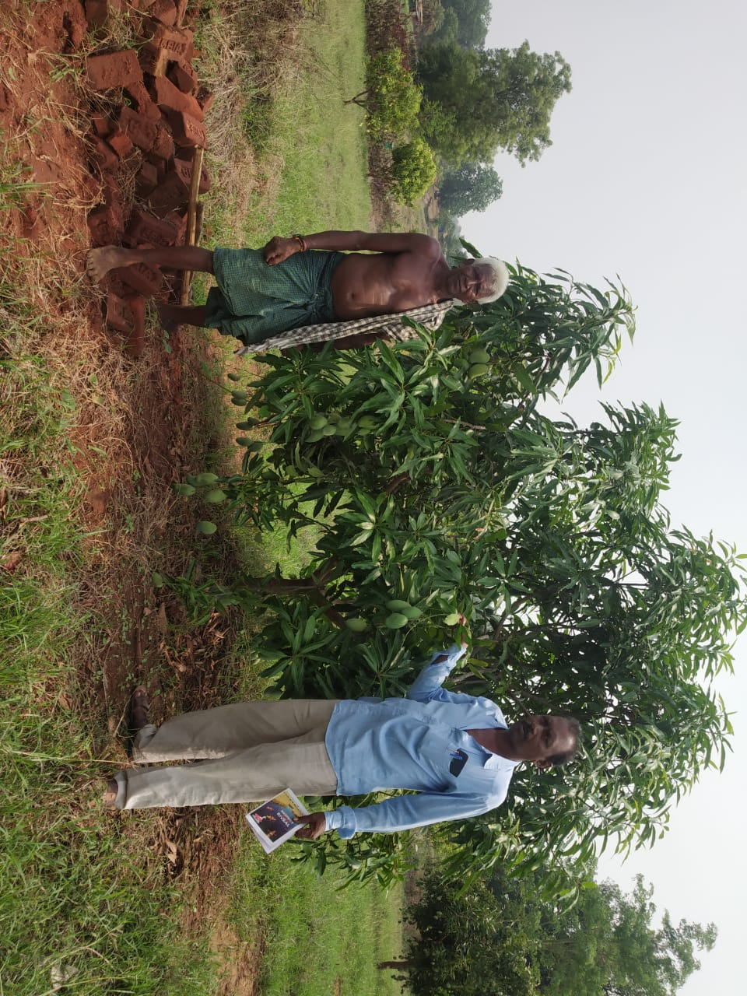

SANJOG
At/Po- Kantabanji
Dist- Bolangir, Odisha
Pin- 767039 (India)
Tel: 9437264453
Fax: +91-6657-221695
Email: SnJ_KBJ@REDIFFMAILCOM /entreprise98@gmail.com

CONTENTS
1.0 FROM THE MEMBER SECRETARY DESK
2.0 THE GENESIS
3.0 VISION AND MISSION
4.0 GEOGRAPHICAL COVERAGE
5.0 TARGET GROUPS
6.0 GOVERNANCE AND WORK ORGANIZATION
7.0 SANJOGA IN ACTION: OVERALL ISSUES ADDRESSED
8.0 DISTRICT INTERVENTION AND ACHIVEMENTS
8.1 FARMER PRODUCER COMPANY
8.2 CLIMATE CHANGE & FARMER RESILENT AGRICULTURE
8.2.1 COMREHENSIVE RICE FALLOW MANAGEMENT (CRFM)
8.2.2 MOVE FOR EARTH- GLOBAL CYCLE RALLY
8.2.3 WORKSHOP ON INDEGENEOUS SEED AND VEGETABLE PRODUCTION-CELEBERATION OF WORLD TRIBALWEEK
8.3. WOMEN EMPOWERMENT
8.3.1 MICRO ENTREPRISE DEVELOPMENT PROGRAMME ON TERACOTTA PRODUCTION & MARKETING
8.3.2 COMMUNITY ENTREPRISES ON NTFP VALUE ADDITION
8.4 INTEGRATED TRIBAL LIVEHOOD PROGRAMME (WADI) IN BELPADA BLOCK
9.0 OUR SUPPOTERS AND COLLABoRATORS
10.0 VISITORS DURING YEAR 2023-24
11.0 Staffs participation IN TRAININGS
12.0. FUTURE PLAN
13.0 EXECUTIVE COMMITTEE MEMBERS
14.0 CASE STUDIES
15.0 AWARDS & Recognisation

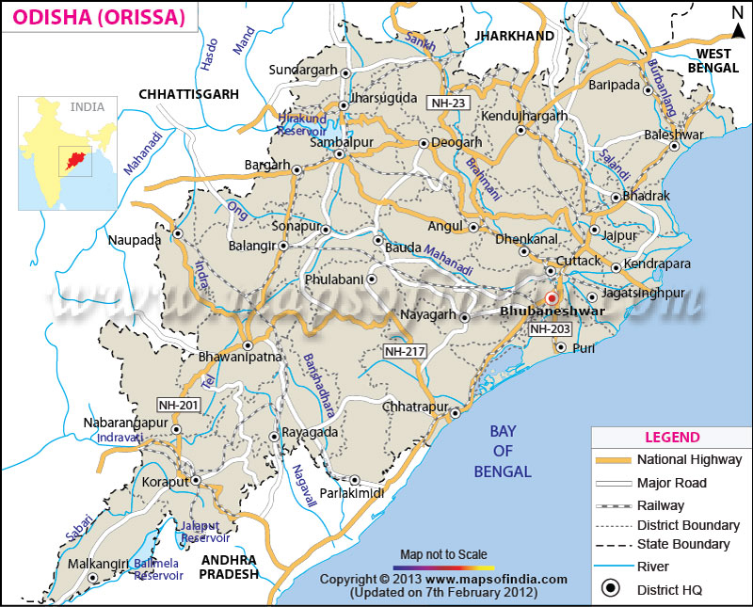

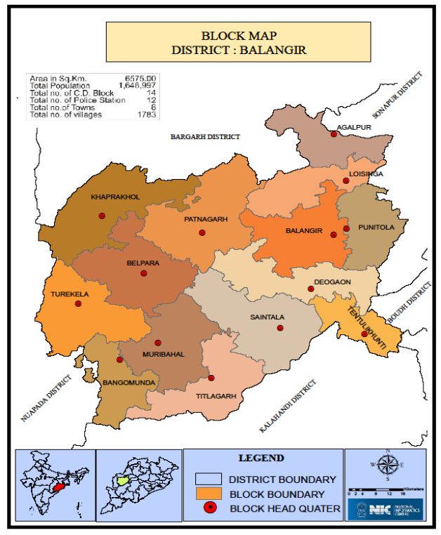 | 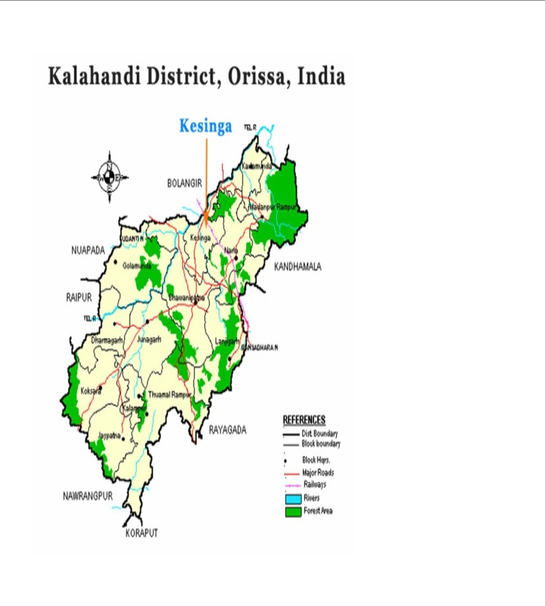

From The Member Secretary Desk

Greetings for New Year 2023-24.

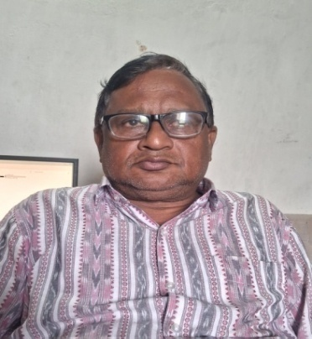
SANJOGA put one step forward of its life span 2023-24.
With the team member’s support & cooperation in decision making, community mobilization, planning & execution of the targeted interventions helped SANJOGA to reach at its mission. During the year the decisions taken to involve more to strengthening community organizations, starting community led enterprises, enhancing capacity of community ,benefitting poorest section of the society and reducing dependency of external support and starting new business models in the area is really helped us to step ahead. The financial support of National Bank for agriculture & Rural Development (NABARD), International Rice research Institute(IRRI),Newdelhi, Switch on foundation (Kolkata), Block Development Office ( Belpada& Agalpur) in Bolangir district, S.Preeti Cashew Industries are real praise worthy, without which more cannot be thought up. The skill up gradation, product development, technology tie up, marketing and other hand holding support provided to WSHGs, Udyan Vikas sammittees(UVS), farmers clubs, Farmers federation, FPOs and entrusted entrepreneurs is no doubt a step forward towards creating a sustainable live hood eco system in a backward economy.

Further we are thankful to agencies extended support for training & individuals for sharing their experiences with us and among them NABARD, Switch on foundation(kolkatta), IRRI, Department of Horticulture, Agriculture & Farmers welfare Department(Govt Of Odisha) , Krushi Vigyan Kendra(Bolangir),Committee for legal aid to poor, Confederation of Indian industry (Bhubaneswar), BIRD(Kolkatta) , Knowledge chamber of commerce & Industry( Ahmedabad) are praise worthy.

We are thankful to our support agencies, collaborators to fulfill the objectives into real action and thank full to functionaries of state, central government agencies, financial institutions those extended heart full cooperation and beneficiaries/ well wishers for their service and contribution.

Jay Bharat.

With thanks

Place: - Kantabanji Kamalesh Kumar Mohanty Date; - 30.05.2024 Member Secretary

2.0 THE GENESIS
“SANJOGA” is a not- for-profit development organization having registered office in Bolangir district started functioning from 1st January 1998. It functions as an autonomous institution with a management consisting of seven members with wide work experience in development sector. It got registered under the Society Registration Act. XII of 1860 in year 1999 having No. 20693/29 of 1999- 2000 at IGR Cuttack,Odisha dated 17.06.1999 with the philosophy that “resource can be optimally utilized by target groups, by a people’s organization/intermediary groups through a process of capacity building , networking , micro level action research and collective marketing which ultimately increase the capacity for self reliance”. Further it is registered under IT Act 1962 No. AABAS509CE20166 date on 24th September 2021. Also registered under section 80G dated on 15.03.2022 and CSR 1 registration no CSR00046736.
3.0 VISION & MISSON
The organization “SANJOG “is built upon and started with the following broad based vision and mission:
- VISION
Promoting a just and equitable society with an integrated approach to help the marginalized sections of the society in mobilizing for self sustaining development organization and build up an institutional base for capacity building of intermediary agencies through micro level action, research, training, networking, documentation and consultancy.
- MISSION
- Sustainable livelihood promotion of rural poor specially women, SC/ ST communities and economically weaker section by organizing self sustained people organization and micro enterprise by utilization of existing skill and effective utilization of credit and resources.
- Enhancement of the technical and managerial skill of artisans/ Producers / NGOs / Farmers /entrepreneurs through organizing capacity building / training programme / workshops / seminars and other form of action programme on experimental basis .
- Increase the access of producers /artisans/ intermediary groups to financial institution and the other source of credit .Conduct participatory study, research and provide a forum for micro entrepreneurs , promote appropriate network among intermediately organization , create lobby and advocacy on their issues .
- Goal:- Building a just equitable and Entrepreneurial society
4.0 Geographical Coverage
The intervention areas cover primarily to two backward districts of Odisha state, ie; Bolangir and Kalahandi. The operational area in Bolangir district covers two blocks, 43 GPs and 187 villages. Similarly Kalahandi district covers one block, 4 Panchayats and 32 Villages. The total operational area is populated with 39% tribal and dalits population. The total work is managed by head office located at Kantabanji and with support of two local administrative offices.
Table-1
State | District | Block | G.P | No. of Villages
 | Bolangir | Bangamunda | 23 | 94
 | Bolangir | Belpada | 20 | 93
 | Kalahandi | M.Rampur | 4 | 32
 |  | Total | 52 | 219
Administrative Office:
Bolangir | Ward No- 12, Birna Road,Kantabanji, Po. – Kantabanji, Dist.- Bolangir,Odisha – 767039  Email – snj_kbj@rediffmail.com, entreprise98@gmail.com  (M) 9437264453,9777339265
Bolangir | At-Dhungiamunda,Po- Kapani Via- Belpada,Dist:- Bolangir-767039,Odisha,M-6370225719
Kalahandi | At/Po.- Mohangiri (Shantipara),Via.- M. Rampur, Dist.- Kalahandi, Odisha-766012,(M) 8018090887, 8895153352
5.0 Target coverage:
Sanjoga is working with 3,340 beneficiaries. The targeted beneficiaries comes under the categories of tribal, dalit , women & other backward communities belongs to small and marginal farmers, migrant workers, artisans/ producers etc.
6.0 Governance and work organization:
The organization adopts a complete democratic process followed by bottom up decision making process. The general body consists of 21 members with appropriate representation of women, tribal and dalit communities. The general body meets at least once a year to transact its mandated business. The governing body constitutes of 7 members who are being elected from general body. The administrative and work organization vests with member secretary as chief executive of the organization. The coordinator and field in charge are guided by respective project heads in consultation with chief functionary. Different sub committees are constituted to review the planning, progress, finance and achievements etc

Organization Structure

GENERAL BODY
( 21 MEMBERS)

EXCUTIVE COMMITTEE

(7 Members)

MEMBER SECRETARY CUM
CHIEF OPERATING OFFICER

BOLANGIR/FIELD UNIT-I
ACCOUNTS &ADM
ADMINSTRATION
Kalahandi
FIELD UNIT -I

ACCOUNTANT (ONE)
Project coordinators(WADI )

FIELD coordinator

OFFICE ASST. (One)

Block Coordinators
FIELD ASSISTANTS (two)

(3 Nos.)

field ASSOCIATES

VDC/UVS/SHG

7.0 SANJOGA in Action: Overall Issues addressed:
The western Odisha especially Bolangir & Kalahandi districts are hemmed with problems of household level food insecurity, interstate migration, chronic poverty, adverse effects of climate change, indebtedness, loss of forest resource and biodiversity. Keeping in view the urgent need, the following issues are beings addressed with community initiative.
- Climate change:
The rural and tribal communities are major inhabitants of the districts of western Odisha, are frequently experiencing the adverse effects of climate change which is manifested in the form of erratic rainfall, drought, high temperature, pest infection, crop loss, water scarcity etc. which has diverse effect on livelihoods of the community as they depend on forest and agriculture produce as main stay of their livelihoods. The communities have taken initiatives to final a way out by different ways and means, such as:-
- Low Crop production:
Agriculture, horticulture and allied activities are the mainstay of livelihoods. Regular Crop failure and low productivity is being experienced. The traditional skill and knowledge of farmers, use of ordinary seed, irregular rainfall, drought like situation, soil degradation, poor farm mechanization, distress sale of labour and produce is a major cause for low production.
- Migration:
In the context of drought, non availability of employment, alienation of productive assets, migration of small and middle pesants, tribal, dalits and landless laborers migrate to urban areas and outside state in search of employment opportunities leading to exploitation and poor quality of life. Both “Pulling” and “Pushing” factors found responsible for distress interstate and intra- state migration. The pushing factors found dominating and compelling result ultimately in destroying.
Regular by crop loss on the one side and lack of employment on the other, the youths from small farmers and agriculture Labour driven by hungry and penury too far off place like Hyderabad, Raipur, Nagpur, Mumbai. Life in a drought year became so unbearable in their own villages even the horror stories in those unfriendly climate recounted by previous migrants fails deter them from leaving their home and health for distant place in search of live-hood. 70% of youth force migrates in search of employment.
- Drought:
Erratic rain fall through a major contributing factor to the problem of recurring drought and distress in the area still does not adequately explain the extremely poverty in which the vast majority of people are living. The people sale their produce at a throw away price. The distress sale of NTFP and Agri produces compel the farmers and poor people to close down their business and migrate to other livelihood.

- Gender and women issues.
The women play an active role in the household economy through participation in agriculture and wage earning. They enjoy a lower social status. But the wages during the agriculture season varies for women ranges from 200 to250/- and male Rs. 250/ to 300/-. Alcoholism among men leads to intra household’s feuds leading to violence against women. Literary percent in the target village is 27% in cases of women. Despite of all sustained effort have led to women rising against injustice heaped in them and their instances when have brought out rallies against alcohol. The consumption of liquor reduces the purchasing power of the family and many family resorts to consumption credit. The women do not have participation in public sphere, especially in public offices or in traditional institutions. The women in panchayatiraj institution are dominated by the males and are not aware on their responsibilities. This puts women in a much disadvantages position. Especially in the enact of marital or any familiar disputes.
Trafficking of women and children primarily found in Kantabanji areas since many years back. Basically women are taken to Luck now, Delhi, Vanaras, Jhansi, Bombay, Nagpur and other places of Uttarpradesh, Madhya Pradesh states for marriage, forced labour and prostitution. This is due to poverty, illiteracy and ignorance.

8.0 District interventions and achievements:
8.1 Farmers Producer Company:-

Besides paddy, horticulture crops (onion, banana,mango,cashew,tamato,chilli) cotton and vegetables are cultivated widely in Bangomunda, Belpada, Muribahal, & Turekela block of Bolangir district. Each year farmer produces approximately 10000 tons onion, value approximately above 4 Crore Rupees. More than 10000 farmers cultivate onion, vegetables, cotton as cash crop each year using local available inputs, skill, technology & traditional practices.
The ignorance in land treatment measures, uses of local available seed, timely credit need, water management, harvest & storing technologies, lack of value addition, distress sale etc. add to woes of farmers in low productivity. During harvest the farmer’s lacks skill on post harvest technologies and inadequate infrastructure facilities for drying and storing. The non remunerative price is also a factor for low productivity. Once the harvest is over, the farmers sold out his raw produces and repay the debt of sahukars. The schemes of state government in supplying seed in late hour, delay farming Practices, inadequate pre and post harvest technologies, training and guidance is not adequate. Considering these factors, the women farmers are federated and registered into a producer company called “Poschima Odisha Women Farmers Producer Company Ltd” has been registered with support of NABARD to take up vegetables, onion, fruits, cashew, mango & marketing programme with initial membership of 413 women farmers. During the year the company has done a business turnover of 9.39 lac of onion, fruits and vegetable seeds. Different training programmes are being organized for benefit of the producer members with support of NABARD during the year.
8.2 CLIMATE CHANGE & FARMER RESILENT AGRICULTURE

8.2.1 Comprehensive Rice Fallow Management Programme(CRFM)

Objectives:-
- To increase the productivity of 2500 hect. Rice fallow land through pulses demonstrations in scientific ways.
- To enhance the income & ensure food security of farmers.
- To enhance the skill, knowledge and managerial capacity of farmers through adoption of technology & package of practices.
- To reduce migration at local level.
During the year 2023-24, 2500 hectors of pulses was cultivated under comprehensive rice fallow management programme in Rabi season with support of International Rice Research Institute (IRRI) and Agriculture & farmers empowerment department, Govt of Odisha in 56 villages of Belpada block in Bolangir district, Odisha. The no of village with crop wise covered area is as follows:-
Block | crop | Area in hect | No of farmers | No of villages
Belpada | Grasspea- | 1000 | 1447 | 38
Belpada | Greengram | 800 | 963 | 27
Belpada | Blackgram | 300 | 401 | 14
Belpada | Chickpea | 400 | 557 | 15
Belpada |  | 2500 | 3368

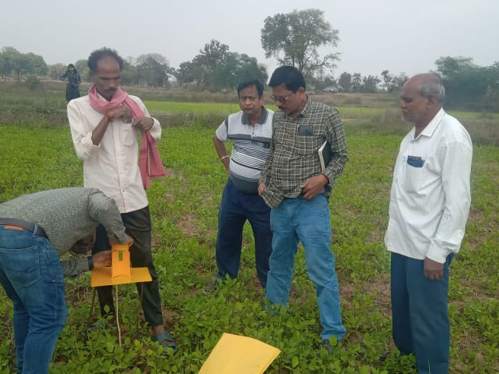
(DISTRICT ORDINATOR, BOLANGIR-CRFM PROJECT & BAO – BELPADA BLOCK VISITING THE CRFM PROJECT SITE- DHUMABHATTA)
At the outset of programme implementation, several round of preliminary meetings at gramapanchayat & village level were organised involving farmers, local elected PRI representatives, shg leaders, extensions staffs of agriculture & farmers empowerment department, farmers clubs members, fpo share holders etc. They were educated on the objectives and proposed activities under rice fallow management programme with focus on pulses demonstration programme and criteria for selection of farmers. The sharing knowledge on package of practises, soil testing, preparation of land, use of improved seed and pest control measures, pre and post harvest technologies to adopt for better yield and income. Further the participants were clarified on scheme objective and final outcome. One to one discussions are made encase any doubt and final beneficiaries list was prepared. In the same day or next day in presence of PRI representatives or extension workers the following volume of seeds and other inputs were distributed to identified farmers as follows with due acknowledgement
slno | Grass pea | Green gram | Black gram | chickpea
1 | Seeds-60000kg | 16000kg | 600Kg | 1600kg
2 | R.culture -200ltr | 160Ltr | 60Ltr | 80ltr
3 | PSB liquid-2500Ltr | 2000ltr | 750Ltr | 100ltr
4 | Solar trap-1000Pc | Boron-4000kg | Boron-1500Kg | Boron-2000Kg
5 | Pheromentrap-8156 pc | Trycoderma-2000Kg | Trycoderma-750Kg | Trycoderma-1000Kg
6 | H.lure-16312Pc | Pendimythalin800ltr | Pendimythalin300ltr | Pendymythalin-400ltr
7 | Yellow sticking Trap-16760Pc | Solar trap-800Pc | Solar trap-300Pc | Solar Trap-400Pc
8 | Blue sticking Trap-16760 Pc | Pheromentrap-6525pc | Pheromantrap-2447 pc | Pheromentrap-3262Pc pc
9 | Pp chemical-100ltr | H.lure-13050Pc | H.lure-4894Pc | H.lure-6524Pc
10 | - | Yellow sticking Trap-13408pc | Yellow sticking trap-5028pc | Yellow sticking Trap-6704Pc
11 | - | Blue sticking Trap-13408 Pc | Blue sticking Trap-5028 Pc | Blue sticking Trap-6704 Pc
12 | - | Imidacloride17.8-112ltr | Imidacloride17.8-42ltr | Propicolazol-40ltr
13 | - | Clorothanil75wp-200kg | Clorothanil75wp-75kg | Clorophyphus-180Ltr
14 | - | Profonofes50Ec-360Ltr | Profonofes50Ec-135Ltr | Clorophyphus 50Ec-100Ltr
Each day the cluster resource persons monitor the farmer’s progress on land preparation, soil conditioning, pre & post soil samples collection for testing etc. During the cultivation/cropping period block coordinator, district coordinator visited the demonstration field and advised the farmers for taking proper care of demos. Technical persons like Chief district agriculture officer, District agriculture officer, Block agriculture officer, assistant agriculture Officer and village agriculture workers have visited the farmer’s field and advised them to take correction measures if any.
The farmers were advised to pluck the pods from crop instead of uprooting the plants. So that the noodles of the plant root will be incorporated in the soil for which soil standards will be enriched.
To know the soil status, one soil sample from each cluster is collected during pre & post cultivation period and deposited with of district soil chemist, Bolangir.
Under the supervision of VAW two crop cuttings from each cluster are completed scientifically to access the productivity enhancement.

Slno | Crop | No of Crop cuttings conducted
1 | Greengram | 66
2 | Blackgram | 33
3 | Grasspea | 82
4 | Chickpea | 32
Salient achievements
- 3368 farmers covered under the CRFM project & enhanced their income
- 2500 hect. Rice fallow land utilised through pulses demonstrations and productivity increased to @ 4 qntls per ac on an average.
- 165 soil samples collected and tested at soil chemist , Bolangir
- 840 farmers trained on package of practices of pulses cultivation through 17 field days.
- 106 barefoot farmer trainers created at local level to carryon activity in future (lead farmers).
- 213 crop cutting completed at field.
- food security ensured at farmers families on pulses use
- Seasonal level migration reduced at local level.
- Positive impact on nearby farmers.
8.2.2 Move for Earth- Global Cycle Rally
With the objective to create awareness among community to save mother earth from various manmade and natural disasters and create pro environment friendly activities, a cycle rally campaign was organized at Beheramunda village on 27th^{d} August 2023. 50 participants from nearby villages joined in the campaign and marched from Beheramunda to Dhungiamunda village with decorative lights, banner, ply cards and speaker with their hands. The programme was supported by Switch on foundation, kolkatta.
8.2.3 WORKSHOP ON INDEGENEOUS SEED AND VEGETABLE PRODUCTION-CELEBERATION OF WORLD TRIBALWEEK;-
On eve of international day of world INDIGINEOUS TRIBAL week celebration one day workshop on indigenous seed and organic vegetable cultivation was organized at Beheramunda panchayat hall on 11.08.2023 in which 50 women farmers were participated. Mr Victor Soren, Block development Officer, Belpada inaugurated the workshop & Mr Jasobanta sahu, BAO (retd) of Belpada Block & Sourav Kumar Dash, horticulture scientist joined as resource person and shared their year long experience on use of indigenous seed, preparation of vermin compost, neem based pest and manure preparation & organic cultivation process. Few women farmer from Beheramunda & Dhungiamunda village shared their experiences. It was organized with support of the switch on foundation, Kolkatta and its representative summed up the feedback of participants & conveyed Vote of thanks to all participants.

8.3. WOMEN EMPOWERMENT
Empowerment of women strata is crucial to the sphere of development process at all level as the women have vibrant participation in the socio-economic development process. The rural women are coming in organized way through SHGs/WSHG in order to address their issues/ problems and meaningful delivery of Services. SANJOGA is playing a vital role in formation and strengthening of SHGs. The SHGs are the instrumental in the process of financial inclusion, covering and mobilizing government development programmes.

8.3.1 MICRO ENTREPRISE DEVELOPMENT PROGRAMME ON TERACOTTA PRODUCTION & MARKETING
Basically the Micro enterprise Development Programme envisages providing skill and capacity on artistic method to pottery works, processing, packaging focusing on value addition and optimum utilization. The inputs required for the project is skill training for raw material collection, processing facility, designing and packaging of finished goods and storage facility.
Presently the collection, processing, production and marketing of pottery items are purely unorganized. Adequate and authenticate information is not available on pottery works relating to quantum of collection, families engaged in collection, demand and supply gap, varieties of production, major sourcing area, products variety, processing industries, marketing source and supportive institutions etc. which are very essential for effective regulation of pottery and terracotta trade in India. Moreover, they forced to sale the pottery items at low prices to middle man and traders. The targeted women are organized in SHG/ joint liability group comprising 4 to 5 in a group, each group having a bank passbook. Pottery products and processing is eco- friendly. The identified beneficiaries are quite habituated with products like earthen pots, flower vessel, earthen saving box,dhupdani,clay lamp and other decorative limited items. The porters families simply collect the raw clay and do the production in traditional way, without any enhanced skill. The components such as skill development, processing, value audition and collective marketing will give fresh impetus to the livelihood in term of supplementing and sustain their livelihoods, generating more income. As such it needs an organized initiative in order to sustain pottery based livelihood of the dependent communities. Hence Sanjoga with support of Nabard taken an initiative to enhance the skill of 30 pottery artisans’ from four matured SHGs taking up terracotta related enterprises

Objectives:-.
- Motivation of 30 women from potter’s family from matured SHGs for entrepreneurship activities.
- Enhancing their managerial and technical skill on terracotta production and raising income.
- Linking them with forward and backward linkages.
- Improve the quality of life of trained potter women through demonstrative sustainable livelihood by introducing household/ community production activities on regular basis.

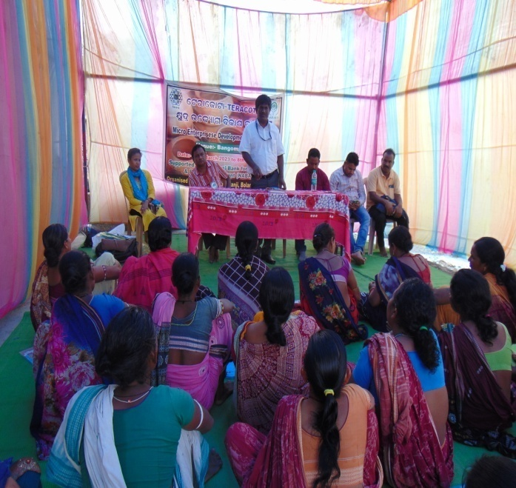  Mr Laxman Soy,DDM,Bolangir, Inaugurating the MEDP on terracotta production | 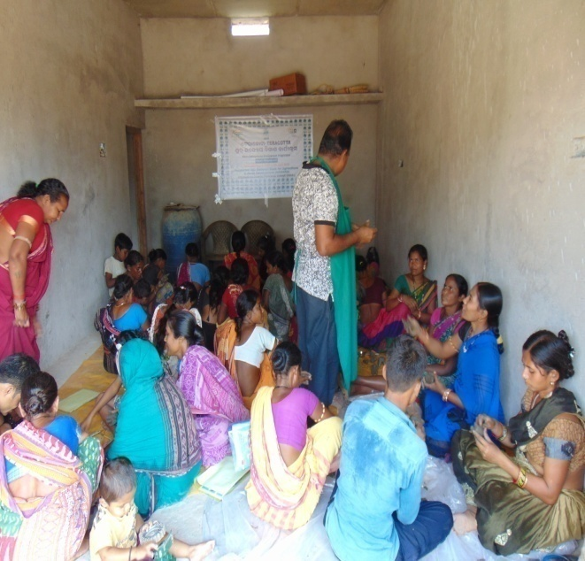  MEDP Training on progress at Bangomunda
Further it aims at adopting on artistic method of pottery works including terracotta production by imparting training and appropriate skill to the women engaged in pottery works. Presently the production in traditional method and traditional items facing problem in marketing due to less demand of buyers. Hence change in design, color and packaging is highly essential. The production is now not in organized way. Considering this with support of NABARD we have organized a 12 days training programme involving 30 women artisans. They were trained under the guidance of master crafts person. Both managerial and technical skill inputs were provided to them .It was conducted from 28th March 2023 to 8th April 2023 at Bangomunda. Mr Laxman Soy DDM, Bolangir inaugurated the programme on 28th March at Bangomunda by lighting the candle. Addressing the participants he shared the purpose of organizing such a programme and details support of NABARD. Further he advised the participants on financial inclusion aspects and avail the benefit of the scheme. Member Secretary from Sanjoga Shared the day wise programme details, timings and practical works the participants have to do within the schedule time frame. Mr Krushna chandra Rana , a member from the artisan community shared his year long experience on terracotta works, present market opportunity etc.
The entrepreneurship Development training covering topics on why entrepreneurship, character of an entrepreneur, business opportunity guidance, market survey, business plan preparation, business leadership and communication, working capital, setting up an unit – step by step procedure, resource mobilization, legal formalities, government scheme, financial inclusion etc. The resource persons were from local banks, EDP expert and Sanjog in house trained personnel. The whole contents cover the idea to motivate SHG member to become a micro entrepreneur. The duration was two days to cover all chapters. Besides this in house trainer/ bankers from Utkal Gramya Bank, Bangomunda branch Mr Parikhita Patra was invited to share details on financial inclusion and other schemes of banks like SHG bank linkage procedure, interest rate , interest subvention etc. Mr Satya Behera , BLC from Mission shakti department was shared his remark on possible collaboration for producer group formation and marketing of products through showroom and exhibitions to be held all over state.
The second phase covers the technical skill training of 10 days duration. The master trainer Mr. Rabindra Kumar Parida imparted skill training on various aspects of pottery works and terracotta products with focuses on raw Clay collection and filtration methods, drying procedure, production of clay lamp, candle stand, Ganesh idols,horse,elephants, standing flower vessel, hanging vessels, horse, tea cup, earthen water jar and other decorative products production on designed way. Group wise practical sessions were conducted. Finally products were sun dried by group and taken for firing at kiln and colored. Latter on quality testing, packaging, costing, marketing, and other Govt. schemes were also taught. Each day session beginning the participants were shared their key learning’s of last day with feedback. Group wise exercise was made to document the whole day activity. The training was started at 11am and ended at 4.30 pm daily.
8.3.2 COMMUNITY ENTREPRISES ON NTFP VALUE ADDITION
banashree forest produce gatherers association (mohangiri, KALAHANDI)
Collection and processing of minor forest produce is the mainstay of livelihoods of the tribal communities in Bolangir and Kalahandi district. It needs to generate more income through multi value addition, storing, processing and marketing.
The tribal women of M.Rampur in Kalahandi and Gudvella (Bolangir) district engaged in collecting sial leaves (Pattal) were build up a federation – “Banashree Forest Produce Gatherers Association” to collect, produce, make value addition and better market involving 27 SHG groups. This federation is running the leaf plate business activities. Machineries and other related equipment created are placed at Mohangiri common facility center. Trained women are working with value added product making ie. Leaf plate (Machine) stitching, thali, dona, using hydrophymatic molding machine. Regular meeting in individual SHG and Federation enhanced their knowledge, skill and practice and widen the market linkages creating better income to families. Sanjoga facilitated the federation members in getting a fair price and better regular market. Now many of the members are earning Rs. 1800 to Rs. 4000 per month through this collective business. 120 women have been trained from six villages in closed stitching leaf plate making and use of molding machine for producing thali and Dona. The finished goods are sold to private traders, business houses, institutions etc. Initially they were confined to collection of loose leaves from forest and sold to private traders at Rs. 25/- per kg or making rough plate sold at a price of Rs. 20/- per 80 pieces. Regular meeting and training in SHGs developed the self confidence and enhanced the technical skill of women primary collectors making plates as per specification with enhanced price. The federation has a done a collective business of 0.77 lac during the year. This collective business created opportunity for primary collectors to earn 30% extra income than before.
8 .4 INTEGRATED TRIBAL LIVEHOOD PROGRAMME (WADI) IN BELPADA BLOCK:-

Sustainable live hood enhancement of 400 tribal families in five villages of Ghagurli and six villages of Beheramunda Gram panchayat of Belpada block in Bolangir district through Orchard development (1st year-100,2nd year-269 , income generation for landless (31 beekeeping) was planned under the WADI project. The geographical location, climate, soil condition of the area is suitable for mango, cashew like horticulture and pulses, vegetable, tamato, oil seed like cash crops. The tribes belongs to Sabar, Munda, Binjhal, Kandha, Gond, Dal sub caste, are well acquainted with forest spices/ horticulture crops and linked with their livelihood over a period of years with support of horticulture, agriculture, animal husbandry, banks, panchayatiraj departments . Further the area comes under a dry region, sandy loom and migration prone. Drought is a regular phenomenon in every alternate year.
The integrated orchard development for tribal communities covering 1 acres of land consisting 15 mango plants in 0.3 acres, 57 cashew plants in 0.7 acres , 100 forest plants in boundary. In short run the tribal will get benefits by introducing intercropping (Pulses, vegetables) and associating them in labour incentive works in the project and later income from sale of fruits/ vegetables and other inter crops collected from orchard on regular basis and its further processing and value addition in long run.
It further aims at integrated development of tribal community focusing on land, water and orchard management aspect through proper soil conservation measures, water resource development, establishment of horticulture orchard, vermin pit construction, intercropping practices reviling in 1 acre land of a tribal farmer field effectively. Regular capacity building, training, demonstration, exposure visit has increased the tribal family’s participation and generating income from horticulture & inter crops. Incase landless the support for beekeeping activities would help them to stand with their own feet within a short period. The health care and women development activities planned will help them to motivate and enhance their capacity, income and collective strength to continue in long run. The farmers’ Producer company build up will manage the whole affairs of project continuity in long run. The project stepped into 5th year (2023-2024) of implementation.;-

Under this projects achievements in the year 2023-24 are given below;-

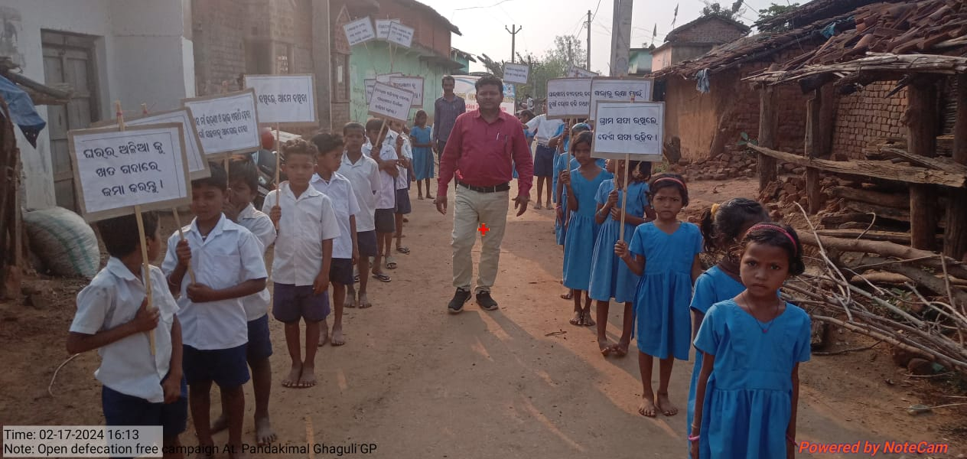
Open Defecation Campaign by School Children at Doramunda Village

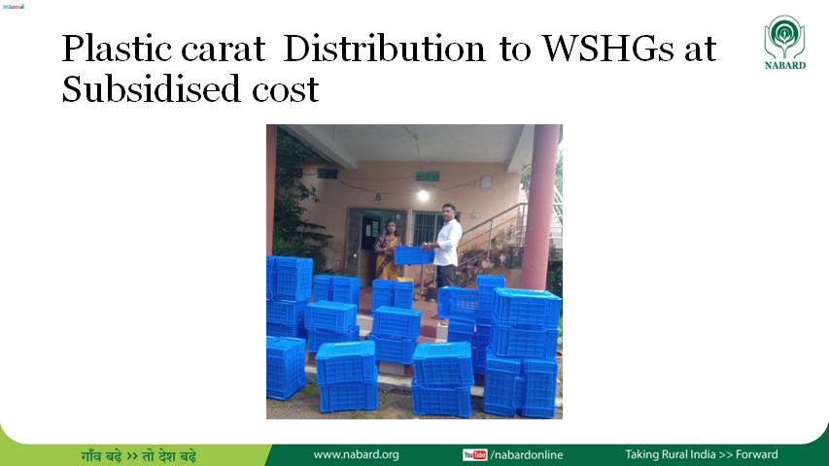

slno | Programmes | Villages | No of UVS /units | Area covered(ac)/units | No Of Farmers/participants
1 | Formation of Udyan Vikas  sammittee (UVS) | Beheramunda,Kadali,Chikili,Pandakimal,Ghagara,Dhungiamunda | 21 | 369 | 394
 | Federation of UVS-Regional Udyan Vikash Farmers Federation(RUVFF) | BeheramundaGp:-Beheramunda, ,Dhungiamunda,Beribera,Mundagaon,Doramunda, Ambabanji  Ghagurli GP:- Kadali,Chikili,Pandakimal,Ghagara,Dumerbahal | One( Regional Udyan Vikash Farmer Federation(RUVFF) | - | 394
2 | Pit Digging & Horticultural Plantation( mango, cashew) | BeheramundaGp:-Beheramunda, ,Dhungiamunda,Beribera,Mundagaon,Doramunda, Ambabanji  Ghagurli GP:- Kadali,Chikili,Pandakimal,Ghagara,Dumerbahal | 21 | 369ac | 394
2 | Intercropping(Tamato,vegetables,chilli,nutrition kit, water melon,pumpkin ) | BeheramundaGp:-Beheramunda, ,Dhungiamunda,Beribera,Mundagaon,Doramunda, Ambabanji  Ghagurli GP:- Kadali,Chikili,Pandakimal,Ghagara,Dumerbahal | 21 | 369ac | 394
 | Verminpits | Beheramunda,Kadali,Ghagara,Pandakimal,dhungiamunda,Dumerbahal,Beribera | 394 | - | 394
3 | Soil conservation works(SCW)
3 | Half-moon Structure | BeheramundaGp:-Beheramunda, ,Dhungiamunda,Beribera,Mundagaon,Doramunda, Ambabanji  Ghagurli GP:- Kadali,Chikili,Pandakimal,Ghagara,Dumerbahal | 21 | 369ac | 394
4 | Water Resource Development(WRD)
4 | Bore well(Electri) | Doramunda,Beribera | 3 | 29ac | 33
4 | Bore well(solar) | Doramunda,Beheramunda,Dhungiamunda,Ghagara,Dumerbahal | 11 | 135 | 135
4 | Pump set | Doramunda,Beheramunda,Dhungiamunda,Ghagara,kadali,pandakimal | 15 | 65 | 136
4 | Drip & sprinkler pipes sets | Doramunda,Beheramunda,Dhungiamunda,Ghagara,kadali,pandakimal | 10 | - | 35
4 | Water Storage Tank(cement) | Beribera,Doramunda,Mundagaon, Beheramunda,Kadali,Chikili,Pandakimal,Ghagara,Dhungiamunda | 46 | 46 nos tank | 46
4 | Water box | Beheramunda,Kadali,Ghagara,Pandakimal,dhungiamunda,Dumerbahal | 2000 | 80ac | 95
4 | WHS | Beheramunda,Kadali,Ghagara,Pandakimal,dhungiamunda,Dumerbahal | 13 | 25 | 94
4 | Earthen storage Tank | Beheramunda,Kadali,Ghagara,Pandakimal,dhungiamunda,Dumerbahal,chikili | 16 | 63 | 205
5 | Other live hood Interventions(Landless families support programmes) | Bee box with beehives | Kadali,Beribera,Dhungiamunda,Beheramunda,Doramunda | 24 families | 165
 | 12 to 13.05.2023 | Orientation training of landless on Bee keeping | Beheramunda | 1nos | 24
 | 3 to 5.06.2023 | Exposure of landless farmers to Beekeeping fields | Kadali | 1nos | 20
6 | WADI PLUS ACTIVITIES | Programmes details | Venue | No of units/programmes | Participants
6 | HEALTH
 | 24.11.2023 | Health camps | Beheramunda | 1camp | 50
 | 24.11.2023 | Health camps | Dhungamunda | 1camp | 26
 | 15.11.2023 | Training on mother & child health | Ghagara | 1camp | 51
 | 17.02.2024 | Open defecation free campaign  Open defecation free campaign | Pandakimal | 1camp/Rally | 38
 | 27.08.2023 | Open defecation free campaign  Open defecation free campaign | Beheramunda | 1 camp | 45
7 | Women development |  |  | -
7 | 8.06.2023 | Streamlining WSHG in Wadi area | Beheramunda | 1nos - | 20
7 | 11.08.203 | Streamlining WSHG in Wadi area | Dhungiamunda | 1 nos | 39
 | 6 to 8.4.2024 | Skill Development of WSHG On NTFP processing | chikili | 1camp | 30
 | 14to 15.062024 | Skill Development of WSHG On NTFP processing | Dhungiamunda | 1camp | 30
8 | Training & capacity Building |  |  | 1 nos | 45
 | 03.04.2023 | Awareness Camp & wadi farmers Sensitization | Dumerbahal | 1nos | 26
 | 28.05.2023 | Capacity building and skill Development of wadi farmers leaders /staffs | Dhungiamunda | 1 nos | 39
 | 11.05.2023 | Training of farmers on post harvest technology | Beheramunda | 1camps | 34
 | 21.08.2023 | Training of farmers on post harvest technology | Dhungiamunda | 1camps | 26
 | 27.01.2024 | Formation & strengthening of Producer Cooperative | Doramunda | 1nos | 48
 | 28.1.2024 | Formation & strengthening of Producer Cooperative | Dhungiamunda | 1nos | 42
 | 21.05.2023 | Exposure of Wadi farmers to Other WADI fields(inter project) | Beheramunda | 1nos | 31

9.0: | Staff Associated with us
Sl No | Name & Designation | Experience
1 | Kamalesh Kumar Mohanty  (Member Secretary cum Chief Executive officer) | 35 years of grass root experience in development field, Specialized in Skill training, rural enterprise promotion, business leadership and communication, entrepreneurship, marketing and livelihood programme. Working as a trainer in conducting EDP programme and trained from EDI as a trainer.
2 | Sushanta Kumar Patro  ( Project Coordinator) till 30th April 2023 | 15 years experience on SHG promotion, micro finance programs, Grass root training, NTFP value added enterprises, rural marketing and Horticulture plantation, Bee keeping etc.
3 | Jyotsna Mayee Behera  (Accountant cum administrative asst) | 2 years work experience in NGO accounting, Tally-ERP 9.0 and office administration.
4 | Sourav Ranjan Dash(Horticulture officer) | Bsc in Horticulture with 3 years of field work experience in horticulture extension programme in Bolangir District.
5 | Ratnakar Mohapatra(Block co- coordinator) | A graduate in commerce with 4 years’ work experience in WADI project implementation( till 31st July 2023)
6 | Nilamber Das(field coordinator) | A graduate with 17 years experience in SHG formation, management and managing NTFP based community enterprises and natural resources management.
7 | Tularam Mallick | Six year experience in Social audit under MGNREGA Programme in Belpada Block
8 | Rajaram Sahu | Six year experience in Social audit under MGNREGA Programme in Agalpur Block
9 | Jagannath Deheria  (Volunteer) | A matriculate with 12 years work experience on community mobilization, conducting skill training and livelihood programme
10 | Pankaj Dip ( Field Coordinator) | A graduate with 13 years work experience in community organization building, organizing skill training, Lac cultivation, Micro credit, Beekeeping, Community based enterprises and natural resources management. Three years experience in Wadi project implementation in Tribal pockets of Bolangir District.
11 | Gouranga Bag( Block Coordinator) | A Matriculate e with 10 years work experience in Shg formation, documentation, organizing skill training, credit linkage and three years experience in wadi Project Implementation.
12 | Bibhisan Kuanar( Block Coordinator) | A graduate with 3 years work experience in community organization building, organizing skill training, Beekeeping, community based enterprises and natural resources management. Three years’ experience in Wadi project implementation in Tribal pockets of Bolangir District
13 | Miss Arati Bhargav( administrative asst) | A graduate with one year experience in office administrative works.

9.0 Our Supporters & Collaborators:-
We believe our partners are our strength. We raise funds through subscription of membership, Donation, Training Fees, Gifts, Consultancy, Grants, and Loans, sales, Service Charges collected from Individual, Institution, and Government & Non Government agencies. Among these following are noteworthy and always praise worthy.
National Bank for Agriculture & Rural Development (NABARD)  Nayapali Civic Centre, Bhubaneswar  www.nabard.org | International Rice Research Institute(IRRI), Newdelhi  wwe.irri.org
 | The Environment Conservation society,(switch on Foundation), Kolkatta, www.switchon.org
Block Development Office, Belpada , Bolangir
Block Development Office, Agalpur , Bolangir | District Development Manager,Nabard,Bolangir
11. Visitors during year 2023-24

Shubhang Gore, Director,  Gore Entrepreneurial Management Institute Nagpur,Maharastra | Mr Sameer Bhanja, AGM,  H.N Sharma, NTPC- Darlipali, Dist:- Sundargarh,Odisha
 | Mr Jangaiah, Manager,Quality Council Of India, Ministry of Commerce, Govt of India,Newdelhi
Mr Victor Soren, Block Development Officer, Belpada, Bolangir | Saileswar Acharya, TDF consultant, Odisha Regional office, Nabard - Bhubaneswar
Dr Vivek Kumar Nayak,District Development Manager, NABARD,Bolangir | Dr Satyamay Satpathy, Senior scientist &head,KVK,Bolangir
Mr Saroj Kumar Chand, State Coordinator, CRFM project, Govt of Odisha, Bhubaneswar | Mr Sujit Bhoi, BAO,Belpada Block,Bolangir
Mr Subash Behera, CDAO, Bolangir | Mr S.R.Pattanaik,AHO,Belpada Block,Dist;- Bolangir
Mr Pramod Kumar Sethy, ADH,Patnagarh | Mr Mihir Kumar Barik, Manager, Switch on Foundation, Bhubaneswar
Josobanta Sahu-Block agriculture officier(Retd),Belpada. | Mr Babuli Charan Sethy, DAO,Patnagarh
Dillip Kumar Raut,  District co ordinator,CRFM project, Bolangir | Tapan Kumar Behera,Pharmacist,Mobile health Unit, Belpada

12.0 Staffs participation in inside and OUTSIDE TRAININGS
Sl | Name of Staffs | desiGnation | Programme details | Duration | Host agency | Venue
1 | Binay Kumar Mohanty | Project Coordinator | MSME Agro international Summit | 22.02.24 | ICC Odisha state council, Bhubaneswar | Hotel swosti Premium,BBSR
1 | Binay Kumar Mohanty | Project Coordinator | Conference & exhibition on millets & food processing | 01.03.2024 | KNOWLEDGE CHAMBER OF COMMERCE & industry,Ahamadabad | HHI,Bhubaneswar
2 | Pankaj dip | Block Coordinator | Training of filled worker | 25.3.23 | Nabard,Bolangir | kvk balangir
2 | Pankaj dip | Block Coordinator | Training on C&D rated FPOs Revival opportunities | 26.10.2023 to 28.10.2023 | BIRD,Kolkatta | S.J.Residency,Bolangir
3 | Bibhisan Kuanar | Block Coordinator | Taining of filled worker | 25.3.23 | Nabard,Bolangir | kvk bolangir
3 | Bibhisan Kuanar | Block Coordinator | TRANNING PROGRAMME on WADI | 11.10.23 to 13.10.2023 | NABARD | CHES, BHUBANESWAR
4 | Gourang Bag | Block Coordinator | training of filled worker | 25.3.23 | Nabard, Bolangir | kvk bolangir
5 | K.K mohanty | Member secretary Cum CEO | Training programme on social stock exchange. | 24.8.to26.8.23 | BIRD KOLKATA | KOLKATA
5 | K.K mohanty | Member secretary Cum CEO | DISTRIBUTED RENEWABLE ENERGY PRESPECTUS AND POTENTIAL IN ODISHA | 22.9.23 | SWITCH On FOUNDATION, KOLKATA | HOTEL SURYANSH, BHUBANESWAR
5 | K.K mohanty | Member secretary Cum CEO | State level Ngo convention on society registration amendment act 2021 with rules 2023 | 28.09.2023 | CLAP,cuttack | Gita Gobinda Sadan,unit 2, Bhubaneswar
5 | K.K mohanty | Member secretary Cum CEO | Annual partners meet | 20 to 21.12.2023 | SWITCH On FOUNDATION, KOLKATA | Eco retreat, Sunsunia,Bankuera,W.B
5 | K.K mohanty | Member secretary Cum CEO | TDF Project Review | 12.03.2024 | NABARD,Bhubaneswar | Nabard conference Hall,Bhubaneswar
6 | LALU PRASAD CHANDAN | Accounts cum ADM ASST | DISTRIBUTED RENEWABLE ENERGY PRESPECTUS AND POTERTIAL IN ODISHA | 22.9.23 | SWITCH On FOUNDATION, KOLKATA | HOTEL SURYANSH BHUBANESWAR
7 | Raghunath Majhi | Wadi farmer | Half yearly TDF Project Review | 12.03.2024 | NABARD,Bhubaneswar | Nabard conference Hall,Bhubaneswar
8 | LALIT MOHAN MAJHI | WADI FARMER | TRANNING PROGRAMME on WADI | 11.10.23 to 13.10.2023 | NABARD | CHES, BHUBANESWAR
10 | JYOTSNA MAYEE BEHERA | Administrative assistant | Training on C&D rated FPOs Revival opportunities | 26.10.2023 to 28.10.2023 | BIRD,Kolkatta | S.J.Residency,Bolangir
12.0 What Next
SANJOGA” on completion of its Twenty six years of life span has been working consistently towards one end poverty reduction, skill development, self employment & women empowerment leading to socio-economic upliftment of the poor community-in Bolangir & Kalahandi district in state of Odisha. The districts are backward one coming under aspirational district identified by NITI Aayog. Irregular rainfall, drought in consecutive years, massive deforestation, interstate migration, distress sale of agro , NTFP, education infrastructures and ill health opened the eye to consider the severity and restore & rebuilding the livelihood processes by utilization of local resources, skill and human power. The challenges –poverty, unemployment, fair Price to producer, reducing distress migration, Conservation of biodiversity – is to mitigate by a model intervention through -micro enterprise promotion & skill training would replicate and bring a long-term change in the lives of poor in the region. The forward and backward linkages for those victimized would be given due importance with trust on farmer, women & children potentiality. The development of human resource by imparting technical skill training, self employment courses, literacy skill, enterprise education & creating scope for capital input to farmers definitely help the large volume of educated unemployed, adolescents, illiterate farmers in distress to contribute to the national income. The collective voices can achieve a lot, a way towards empowerment of the society, by formation & strengthen of self-help movement, building micro financing institution, farmer’s producer group in the Region. Health care aspects with thrust on women health, nutrition for children, malaria control would integrate with ongoing activities in coming days.
13. Executive Committee Members
Sl. | Name | Designation | Address | Qualification | Profession
1 | Mr Ashok Kumar Das | Chairman | Ashok Nagar,At/po-Kantabanji,Dist-Bolangir | B.A.LLB | Advocate
2 | Mr Pandav Swain | Vice Chairman | At-Durga Bazar,po-Dasapalla,dist-Nayagarh | Bsc (AG) | Social work
3 | Mr. K.K. Mohanty | Member Secretary | At/po-Kantabanji,Dist-Bolangir,Odisha | M.A(DRD) | Social Work
4 | Mr. Amarendra Ku Sethy | Joint Secretary | At-Gorubazar,Po-Bolangir,Dist-Bolangir | M.A,BEd,M Phil | Teaching
5 | Ms Jyosthnabala Tripathy | Treasurer | At-Bambilo,po-Basandara,Via-Biridi road,Dist-Jagatsingpur | BA(Hons) | Social work
6 | Mrs Rama Majhi | Member | At/po-Mohangiri,via-M.Rampur,Dist-Kalahandi | 7th | House wife
7 | Sushanta Kumar Patro | Member | At/po:- Purushatam Prasad,Via:- handapadaDist-Nayagarh,Odisha | M.A | Social Work

****************************************o***************************************************

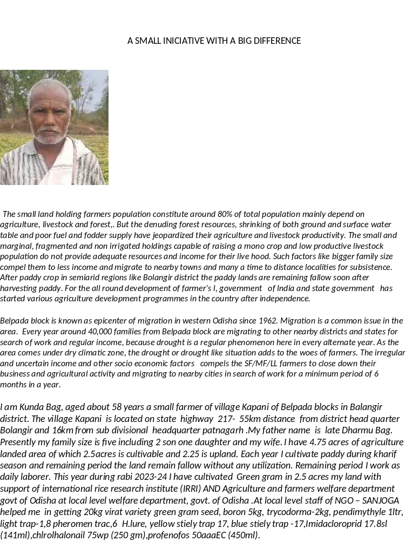

I am Kunda Bag, aged about 58 years a small farmer of village Kapani of Belpada blocks in Balangir district. The village Kapani is located on state highway 217- 55km distance from district head quarter Bolangir and 16km from sub divisional headquarter patnagarh .My father name is late Dharmu Bag. Presently my family size is five including 2 son one daughter and my wife. I have 4.75 acres of agriculture landed area of which 2.5acres is cultivable and 2.25 is upland. Each year I cultivate paddy during kharif season and remaining period the land remain fallow without any utilization. Remaining period I work as daily laborer. This year during rabi 2023-24 I have cultivated Green gram in 2.5 acres my land with support of international rice research institute (IRRI) AND Agriculture and farmers welfare department govt of Odisha at local level welfare department, govt. of Odisha .At local level staff of NGO – SANJOGA helped me in getting 20kg virat variety green gram seed, boron 5kg, trycodorma-2kg, pendimythyle 1ltr, light trap-1,8 pheromen trac,6 H.lure, yellow stiely trap 17, blue stiely trap -17,Imidacloroprid 17.8sl (141ml),chlrolhalonail 75wp (250 gm),profenofos 50aaaEC (450ml).
I adopted a scientific process of cultivation and applied all techniques. Completed the cultivation and applied all techniques completed the land preparation, applied boron and trycodorma for soil conditioning and sowed greengram seeds. The climate condition was favorable and growth of plants was impressing. A display board was placed on demo plot containing name of village, crop, and NGO and support source. Both pre and post soil test of the plot was made. When green gram crop was floated with flowering phenomena trap and lytheyan traps were hanged inside the crop to protect the crop from pests attack. In the mean time rain fall occurred for two consecutive times. Intercultural operation was taken up at required time. I started plucking of green gram buds from end of March month with help of whole family member.
With support of local VAW of agricultural department crop cutting experiment taken up in my field. I have harvested 7q 40kg green gram.
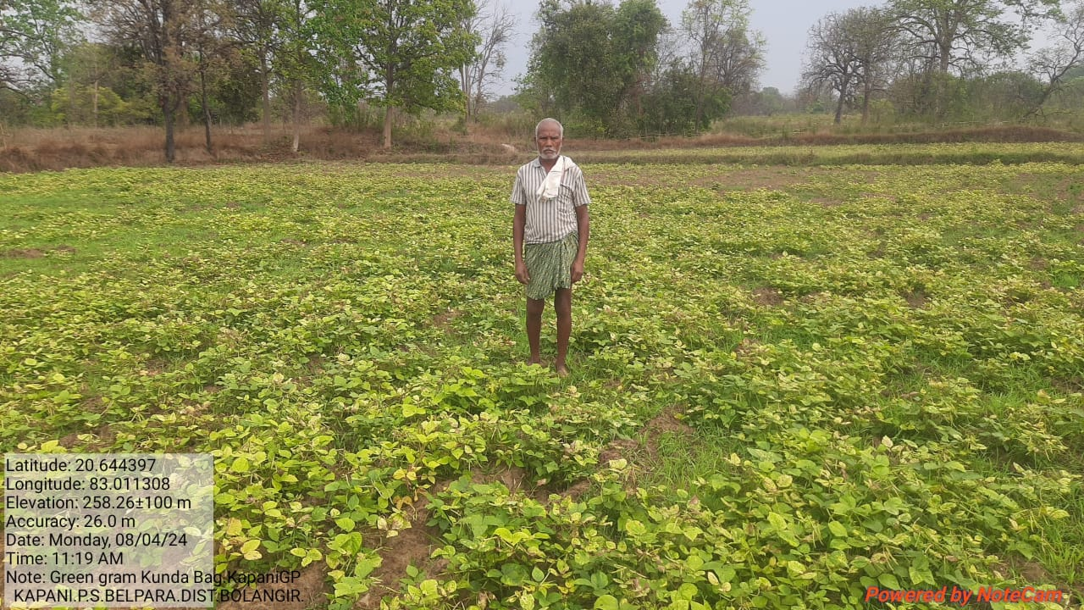
Almost double of last year production. Storing a portion of production 40 kg for family consumption purpose, the remaining surplus 7 quintal sold at the local market and earned 56,000.
I am feeling proud and thankful to IRRI & Agriculture and farmer’s welfare department govt of Odisha, local NGO coordination for their timely supply of inputs, technical and entrepreneurial support for which I am proud of to be a successful farmer.
On being asked about his future plan he expressed his ambition to expand his cultivation area in coming year in a systematic and scientific way without any external support.

I am happy for my small initiatives which made a great learning and a big difference.

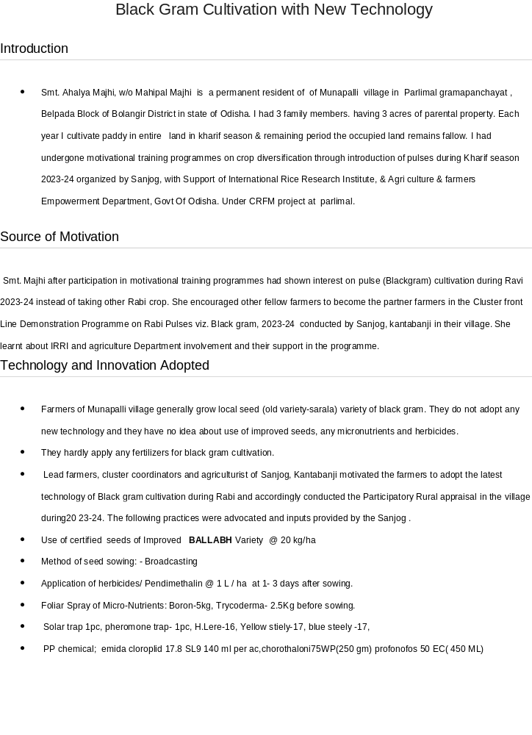

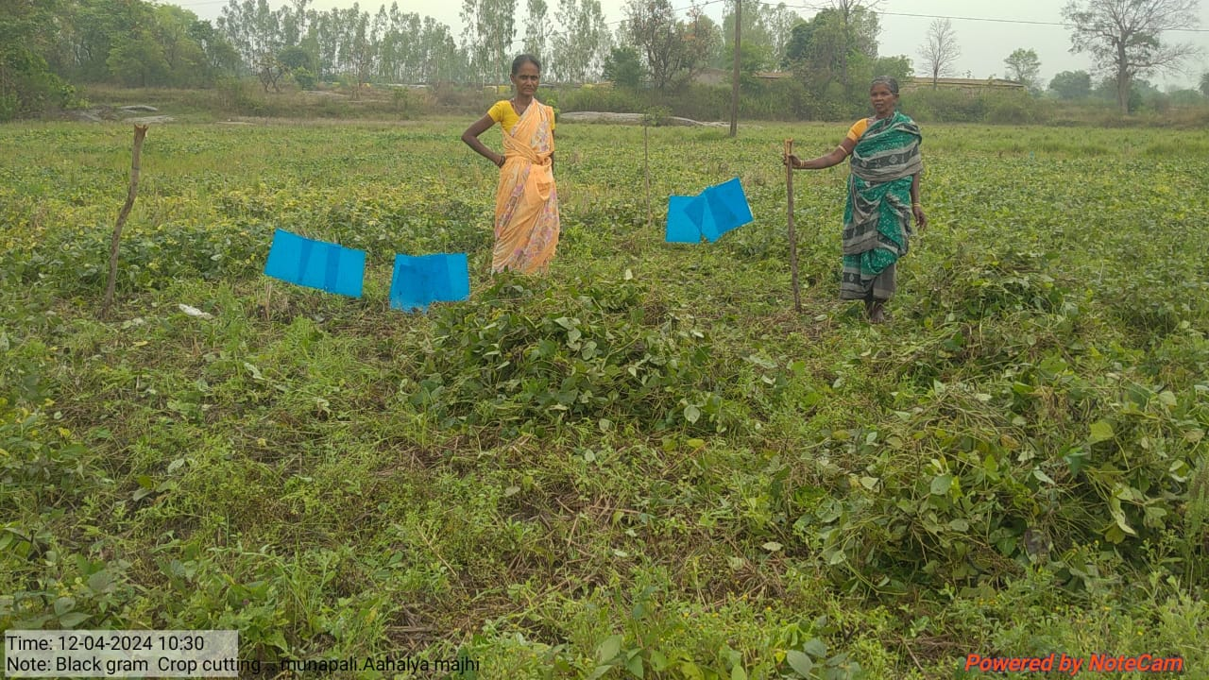

Achievements
Local Check |  |  | Demonstration
Varity | Yield(q/ha) | BC Ratio | Variety | Yield (q/ha) | BC Ratio | Change in Yield (%)
Sarala | 1.68 | 1.94 | VALLABH | 3.68 | 4.16 | 127

Contributing Factors
- The demonstrated variety Vallabh is a short duration and takes 15-20 days less than the existing local variety.
- Average no. of branches of the demonstrated variety was also more by 6-8 numbers than the sarala variety. The number of pods per plant was 60-65 in the demonstrated variety whereas in the case of the existing variety, it was only 30-35 in numbers.
- The shiny black colour of the seeds of Ballabh is very much attractive and fetches higher remuneration in market.

Influence on the Other Farmers
- The demonstration plots attracted the attention of many farmers for its good crop stand and a bumper harvest. It is expected that people would adopt this improved/new technology to boost pulse production.

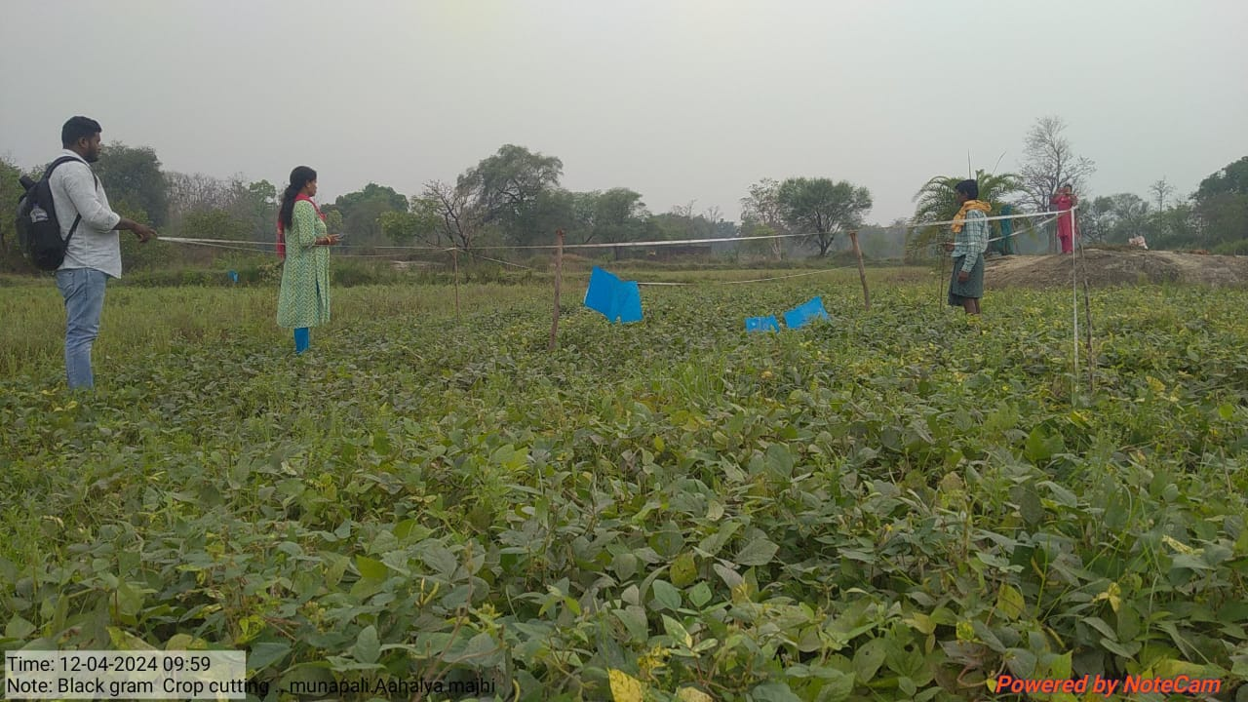
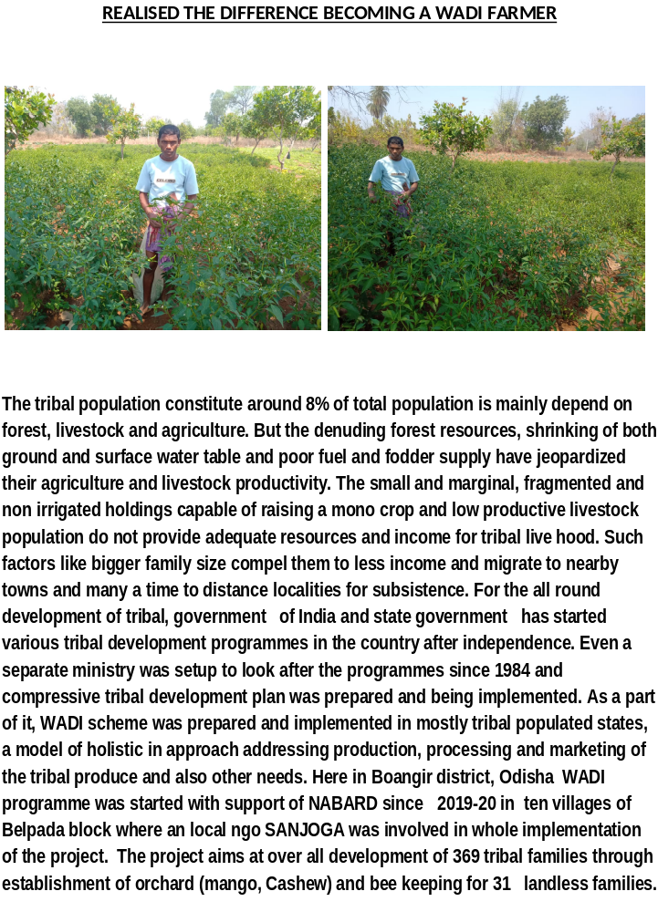
Belpada block is known as epicenter of migration in western Odisha since 1962. Migration is a common issue in the area. Every year around 30,000 families from Belpada block are migrating to other nearby districts and states for search of work and regular income, because drought is a regular phenomenon here in every alternate year. As the area comes under dry climatic zone, the drought or drought like situation adds to the woes of farmers. The irregular and uncertain income and other socio economic factors compels the SF/MF/LL farmers to close down their business and agricultural activity and migrating to nearby cities in search of work for a minimum period of 6 months in a year.
Mr Lingaraj Bhue, S/o-Ranjit Bhue is a small farmer of Village Beribera in Beheramunda gramapanchayat in Belpada Block of Bolangir District. The Village is 10 km distance from Block head quarter Belpada and 80 km from district head quarter Bolangir. He is the second son of elder son of his parents. Presently his family size is four including one son and one daughter. He belongs to a scheduled tribe family. His age is about 46 years. He owns only 3 acres of cultivable land including one acre of upland.
Each year I regularly cultivate paddy in lowland, cotton in upland during kharif season and earn harvest 7/8 quintals of paddy per year. Further 2000/- net earnings I receive from cotton cultivation early after deducting seeds, fertilizer, and other labour charges. Later I get information regarding Sanjog an ngo started WADI programme in our village in year 2019-20. It was the year covid -19 was spreading slowly. They conducted several rounds of meeting and surveys in our village and finalized the farmers. Including me other 17 farmers of Beribera cluster agreed on the proposal and gave their consent to enroll them as a farmer. I had an idea that KBK region is most suitable for horticultural crops like mango, guava, lemon, custard apples and vegetables even if in low irrigation facilities. We had formed a Udyan vikash sammittee named Sabuja Uyan Vikash committee involving all wadi farmers.
As a wadi farmer I had planted 57 no cashew (V-4) and mango 15 no (Dushhary,amrapally,Mallika) in year 2019-20 supplied by Ngo. Contributed labor for pit digging, planting, stacking, filling of pits, half-moon construction around the plant, cleaning, manure application, irrigation etc in my one acre wadi . On convergence mode one lift irrigation points was bored and installed. I became delighted and started tomato cultivation as inter crop. JK DESI variety seed was used in nursery rising and plantation. The watch and ward activity was taken care by me. My production was started from November 2021 end. I used to sell the produce at local Belpada and Ghagurli weekly bazar on cash. This year I had cultivated chilli during Ravi 2023 and realized 50,000/- only. Further due to continuous rain fall in July month my chilli crop was partly damaged. In comparison to traditional crop return the amount is doubled almost.
Each day my family members support me in vegetable growing activity like plant care, irrigation, weeding, application of manure, fertilizer and pesticide, harvesting of produces, grading and selling of it.
My productivity of chilli per half acre is approximately 500 kg, quite satisfactory and encouraging for others and I have not faced any problem to sale my produces at local market. The average sale price is 50/- per kg for green and Rs 250 for dry kg. Further earned 5000/- from sale of cashew this year.

Like other family I had not migrated and promised to stay in village. My income within a short period has build up my confidence and strength.
I advise all farmers not to leave village as there is ample scope of work and income at Village.
I am hopeful after another 2 years regular income would come from my WADI field for a longer period. I am grateful to NABARD for supporting tribal farmers like me under WADI programme.
On being asked about his future plans, he expressed his ambition to expand his vegetable cultivation area and supply to nearest town at a better price and earning. Further plans to start a cold chamber at lower cost with support of Government scheme.
So I realized the difference becoming a WADI farmer and motivated others to actively participate in it.

REALISED THE DIFFERENCE BECOMING A WADI FARMER

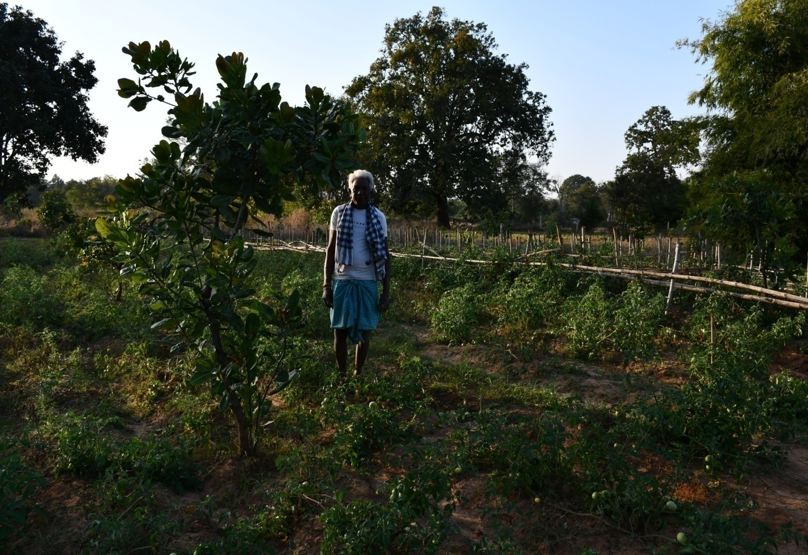
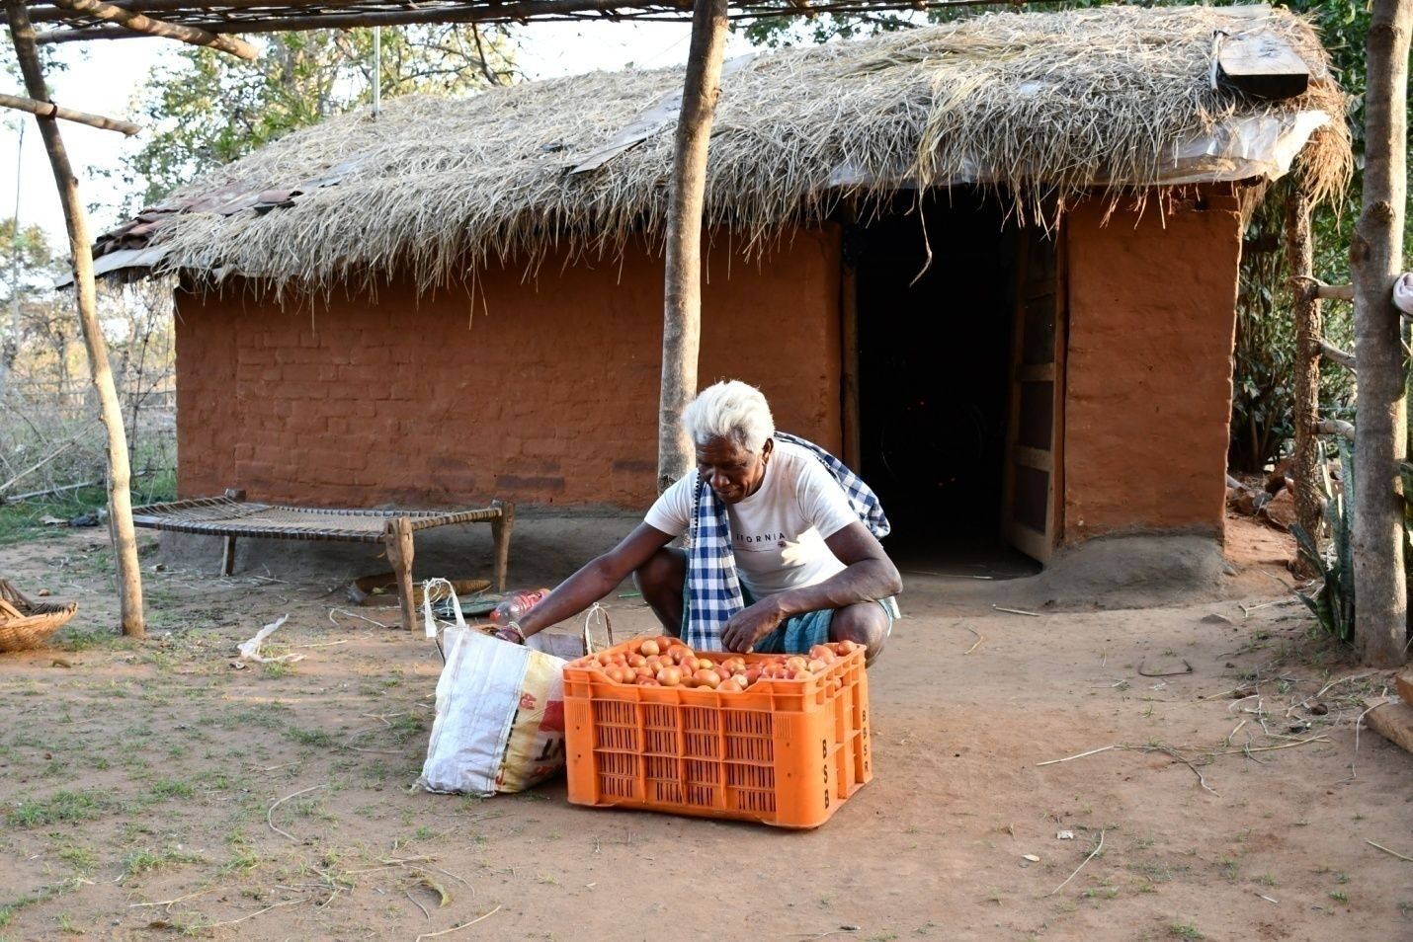
The tribal population constitute around 8% of total population is mainly depend on forest, livestock and agriculture. But the denuding forest resources, shrinking of both ground and surface water table and poor fuel and fodder supply have jeopardized their agriculture and livestock productivity. The small and marginal, fragmented and non irrigated holdings capable of raising a mono crop and low productive livestock population do not provide adequate resources and income for tribal live hood. Such factors like bigger family size compel them to less income and migrate to nearby towns and many a time to distance localities for subsistence. For the all round development of tribal govt. of India and state government started various tribal development programmes in the country after independence. Even a separate ministry was setup to look after the programmes since 1984 and compressive tribal development plan was prepared and implemented. As a part of it, WADI scheme was prepared and implemented in mostly tribal populated states, a model of holistic in approach addressing production, processing and marketing of the tribal produce and also other needs. Here in Belpada block of Boangir district,Odisha WADI programme was started with support of NABARD since 2018-19 financial year. The project aims at over all development of 400 tribal families through establishment of orchard ( mango,Cashew) and bee keeping for landless farmers.
Migration is a common issue in the area. Every year around 30,000 families from Belpada block are migrating to other nearby places for search of work and regular income because drought is a regular phenomenon in every alternate year. As the area comes under dry climatic zone, the drought or drought like situation add to the woes of farmers .The irregular income and other socio economic factors compels the SF/MF/LL farmers to close down their business , agricultural activity and migrating to nearby cities in search of untraditional work for a minimum period of 6 months in a year.
Mr Lakhyapati Majhi, S/o-late Banamali Majhi is a small farmer of Village Behera munda in Belpada Block of Bolangir District. The Village is 14 km distance from Block head quarter Belpada and 70 km from district head quarter Bolangir. He is the second son of his parents. Presently his family size is seven including one unmarried son and one daughter. Three sons and two daughters are already married. His wife is passed away since twelve years. He belongs to a scheduled tribe family. His age is about 65 years. He owns only 2 acres of cultivable land four acres of upland. Remembering his early youth stage he was migrating to other places for brick kiln works. But after 1992 I was used to start cultivation of my own.
Like other years this year I have cultivated pulses and vegetables and earn 60 to 70 thousand. Later I got information regarding Sanjog an ngo started WADI programme in our village in year 2020-21.They conducted several rounds of meeting and surveys in our village and selected the farmers. Including me other 25 farmers of our cluster in Beheramunda village agreed on the proposal and gave their consent to include them as a farmer. I had an idea that KBK region is most suitable for horticultural crops like mango, guava, lemon, custard apples and vegetables even if in low irrigation facilities. We had formed a Udyan vikash committee named Maa Grameeya Thakurani UVs involving all identified wadi farmers.
As a wadi farmer I had planted 57 no cashew (V-4) and mango 15 no (Dushhary,amrapally,Mallika, Bombay green, Keshar)
In year 2020-21. Contributed labor for pit digging, planting, stacking, filling of pits, half-moon structure around the plant, cleaning, manure application, irrigation etc in my one acre wadi land. One electric motor with pipes was supplied to the UVS out of NABARD support for watering plants. Further two WHS were constructed at lower portion of Wadi field in same year. I became delighted and started tomato cultivation as inter crop. Laxmi variety seed was used in nursery rising and plantation. Besides tamato cowpea and pumpkin crop added to income during the season. The watch and ward activity was taken care by me. Each day I take care of my plants. Fortunately a solar operated bore well was installed in the patch with NABARD support. My hope became doubled and thanked to NABARD for supporting at this critical period. My inter crop production was started from November month end. I used to sell the produce at local Belpada,Mundagaon and Ghaguli weekly bazaars on cash. This year tamato sale price was Rs 300 per carate- 20 kg approximately and I realized 70,000/- from tomato sale only. Further due to unexpected rain fall in February & March month my tamato crop was partly damaged. In comparison to traditional crop return the amount is doubled almost.
Each day my family members support me in vegetable growing activity like plant care, irrigation, weeding, application of manure, fertilizer and pesticide control, harvesting of produces, grading and selling of it.
My productivity of tomato per acre is approximately 3000 kg , quite satisfactory and encouraging for others and I have not faced any problem to sale my produces at local market. The average sale price is 20/- per kg.
Like other family in my village I had not migrated and promised to stay in village. My income within a short period builds up my confidence and strength. I had recently completed marriage of my middle son out of my agriculture income.
I advise all farmers not to leave village as there is ample scope of work and income at Village.
I am hopeful after another 2 years regular income would come from my WADI field for a longer period. I am grateful to NABARD for supporting tribal farmers like me under WADI such a programme.
On being asked about his future plans, he expressed his ambition to expand his vegetable cultivation area and supply to nearest town at a better price and earning. Further plans to start a storage chamber at lower cost with support of Government scheme.
Testimony: We are really thankful to NABARD and Sanjoga who has given opportunity to Us and we are confident enough now that we can live without support of others and our collective strength is our strength.

AWARDS & RECOGNISATIONS

