Hard Labour never goes unreward

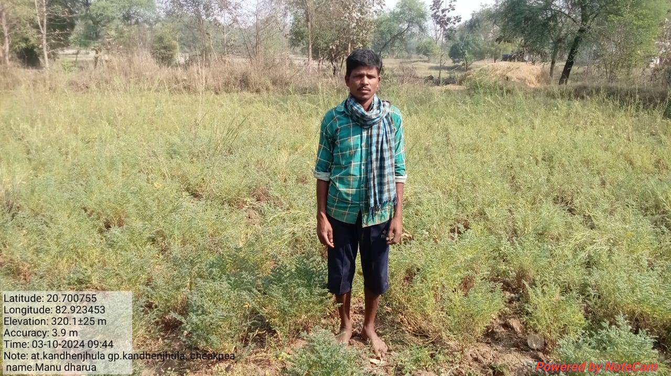

I am Manu Dharua; S/o of Ladu Dharua, aged about 38 years is a small land holding farmer of kandhenjhula Village in Belpada Block of Bolangir District. He is a dropout from 5th class from his village Government school, kandhenjhula. Since my childhood I have interest in farming and always help my parents in season work. He has a landed property of 3.5 acres from which he cultivates chickpea in one acre and remaining land remains fallow after paddy cultivation in rabi season He found besides paddy cultivation in kharif season each year his land is remaining fallow without any productive purpose. It is not suitable for other crops and lack of irrigation facilities. Mr Dharua identified as one of beneficiary for the cultivation of chickpea in 1 hectorof land.
With the support of IRRI and Agriculture and farmers welfare department, Govt. of Odisha, implemented the rice fellow management programme in the Belpada block during Rabi 2023-24. Under the project a meeting of farmers of village was conducted & discussed on objective of the scheme and support etc. Mr Ashis Punji VAW from Agriculture Department was also participated as expert and shared knowledge on package of practices on scientific process of cultivation including land preparation, soil testing, application of pest control measures, irrigation control, weed control, harvesting procedure etc.
Manu was supported the JG ii variety 40 kg seed and required inputs like R.culture 200ml, PSB 2500ml,Pendimythyle 1000ml, Boron 5kg,trycoderma 2.5 kg,solar 1pc,Pheromen trap- 8pc, H.lure-16 pc,PPchemical, clorophyphus 200Ec from the project with guidance of the field staff. He followed the package of practices of Chickpea cultivation. He also cultivated the land in time and applied all the provided micronutrients in the time. When flowering started he putted the solar trap, yellow sticky trap and the pheromone trap in the crop field to protect the effect from pests attack. Periodic visit of VAW clarified his doubts relating technical aspects of plants growth; inter culture operation, irrigation management and harvest.
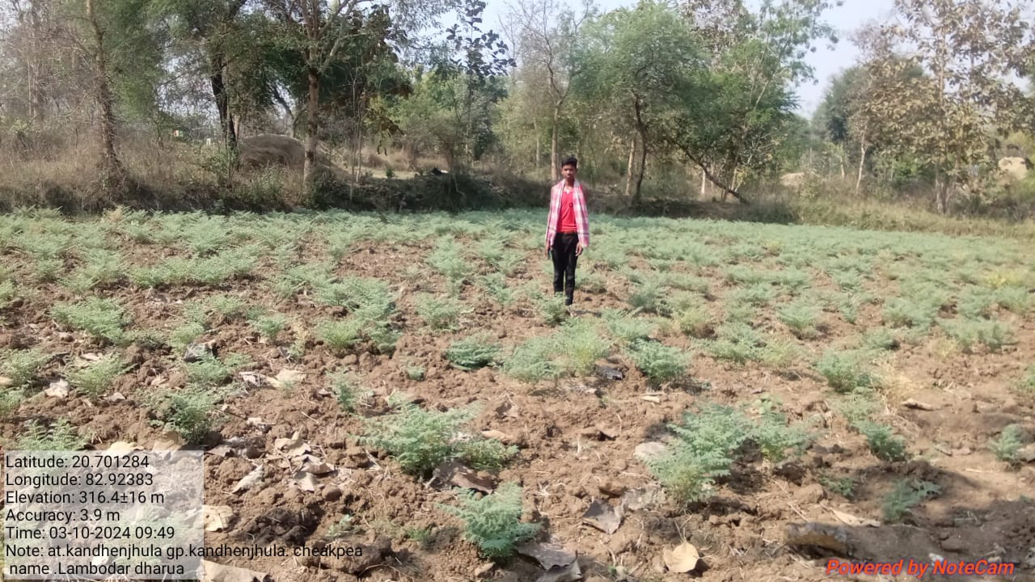

Manu Dharua harvested 3.5 quintal chickpea from one hector of land which sold at Rs.12, 000. Within a period of 4 months and earned huge amount from a fallow lands
He said due to introduction of new technology, certified seed, inputs in proper time Under the CRFM project, the small farmers are getting more benefit. He is very happy and thankful to the IRRI, Agriculture & farmers Welfare Department and SANJOGA.

