REALISED THE DIFFERENCE BECOMING A WADI FARMER

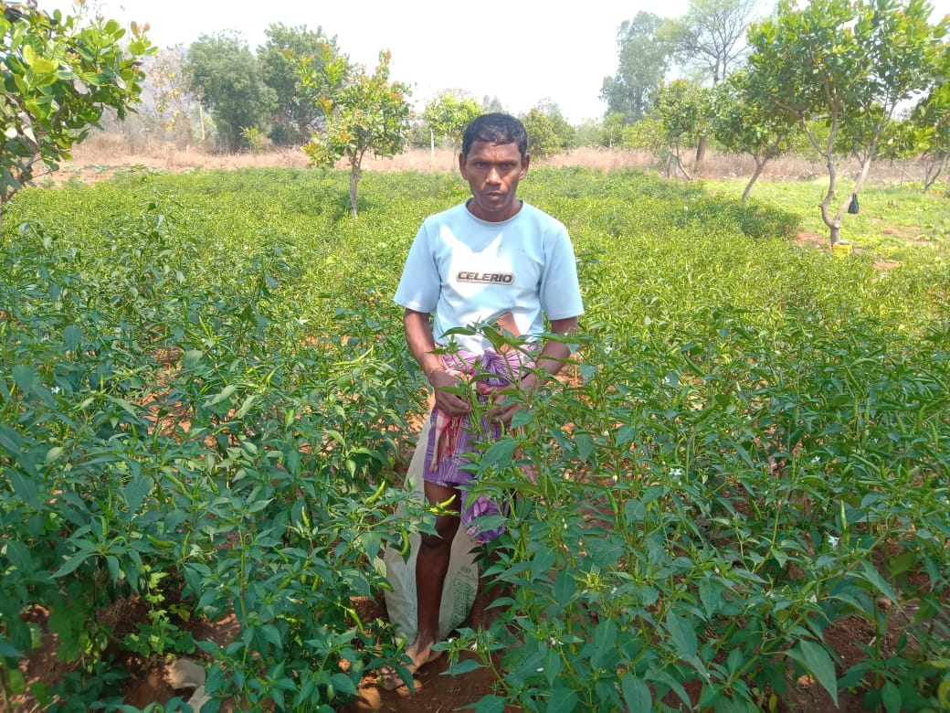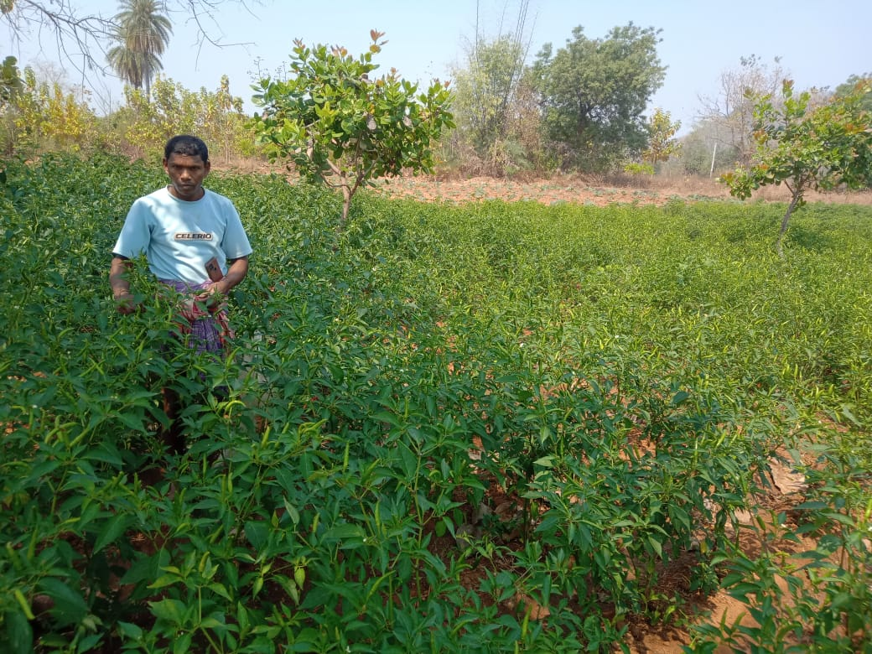

The tribal population constitute around 8% of total population is mainly depend on forest, livestock and agriculture. But the denuding forest resources, shrinking of both ground and surface water table and poor fuel and fodder supply have jeopardized their agriculture and livestock productivity. The small and marginal, fragmented and non irrigated holdings capable of raising a mono crop and low productive livestock population do not provide adequate resources and income for tribal live hood. Such factors like bigger family size compel them to less income and migrate to nearby towns and many a time to distance localities for subsistence. For the all round development of tribal, government of India and state government has started various tribal development programmes in the country after independence. Even a separate ministry was setup to look after the programmes since 1984 and compressive tribal development plan was prepared and being implemented. As a part of it, WADI scheme was prepared and implemented in mostly tribal populated states, a model of holistic in approach addressing production, processing and marketing of the tribal produce and also other needs. Here in Boangir district, Odisha WADI programme was started with support of NABARD since 2019-20 in ten villages of Belpada block where an local ngo SANJOGA was involved in whole implementation of the project. The project aims at over all development of 369 tribal families through establishment of orchard (mango, Cashew) and bee keeping for 31 landless families.
Belpada block is known as epicenter of migration in western Odisha since 1962. Migration is a common issue in the area. Every year around 30,000 families from Belpada block are migrating to other nearby districts and states for search of work and regular income, because drought is a regular phenomenon here in every alternate year. As the area comes under dry climatic zone, the drought or drought like situation adds to the woes of farmers. The irregular and uncertain income and other socio economic factors compels the SF/MF/LL farmers to close down their business and agricultural activity and migrating to nearby cities in search of work for a minimum period of 6 months in a year.
Mr Lingaraj Bhue, S/o-Ranjit Bhue is a small farmer of Village Beribera in Beheramunda gramapanchayat in Belpada Block of Bolangir District. The Village is 10 km distance from Block head quarter Belpada and 80 km from district head quarter Bolangir. He is the second son of elder son of his parents. Presently his family size is four including one son and one daughter. He belongs to a scheduled tribe family. His age is about 46 years. He owns only 3 acres of cultivable land including one acre of upland.
Each year I regularly cultivate paddy in lowland, cotton in upland during kharif season and earn harvest 7/8 quintals of paddy per year. Further 2000/- net earnings I receive from cotton cultivation early after deducting seeds, fertilizer, and other labour charges. Later I get information regarding Sanjog an ngo started WADI programme in our village in year 2019-20. It was the year covid -19 was spreading slowly. They conducted several rounds of meeting and surveys in our village and finalized the farmers. Including me other 17 farmers of Beribera cluster agreed on the proposal and gave their consent to enroll them as a farmer. I had an idea that KBK region is most suitable for horticultural crops like mango, guava, lemon, custard apples and vegetables even if in low irrigation facilities. We had formed a Udyan vikash sammittee named Sabuja Uyan Vikash committee involving all wadi farmers.
As a wadi farmer I had planted 57 no cashew (V-4) and mango 15 no (Dushhary,amrapally,Mallika) in year 2019-20 supplied by Ngo. Contributed labor for pit digging, planting, stacking, filling of pits, half-moon construction around the plant, cleaning, manure application, irrigation etc in my one acre wadi . On convergence mode one lift irrigation points was bored and installed. I became delighted and started tomato cultivation as inter crop. JK DESI variety seed was used in nursery rising and plantation. The watch and ward activity was taken care by me. My production was started from November 2021 end. I used to sell the produce at local Belpada and Ghagurli weekly bazar on cash. This year I had cultivated chilli during Ravi 2023 and realized 50,000/- only. Further due to continuous rain fall in July month my chilli crop was partly damaged. In comparison to traditional crop return the amount is doubled almost.
Each day my family members support me in vegetable growing activity like plant care, irrigation, weeding, application of manure, fertilizer and pesticide, harvesting of produces, grading and selling of it.
My productivity of chilli per half acre is approximately 500 kg, quite satisfactory and encouraging for others and I have not faced any problem to sale my produces at local market. The average sale price is 50/- per kg for green and Rs 250 for dry kg. Further earned 5000/- from sale of cashew this year.
Like other family I had not migrated and promised to stay in village. My income within a short period has build up my confidence and strength.
I advise all farmers not to leave village as there is ample scope of work and income at Village.
I am hopeful after another 2 years regular income would come from my WADI field for a longer period. I am grateful to NABARD for supporting tribal farmers like me under WADI programme.
On being asked about his future plans, he expressed his ambition to expand his vegetable cultivation area and supply to nearest town at a better price and earning. Further plans to start a cold chamber at lower cost with support of Government scheme.
So I realized the difference becoming a WADI farmer and motivated others to actively participate in it.

