BLOOMING LIVES OF MIGRANT WOMEN THROUGH SHG

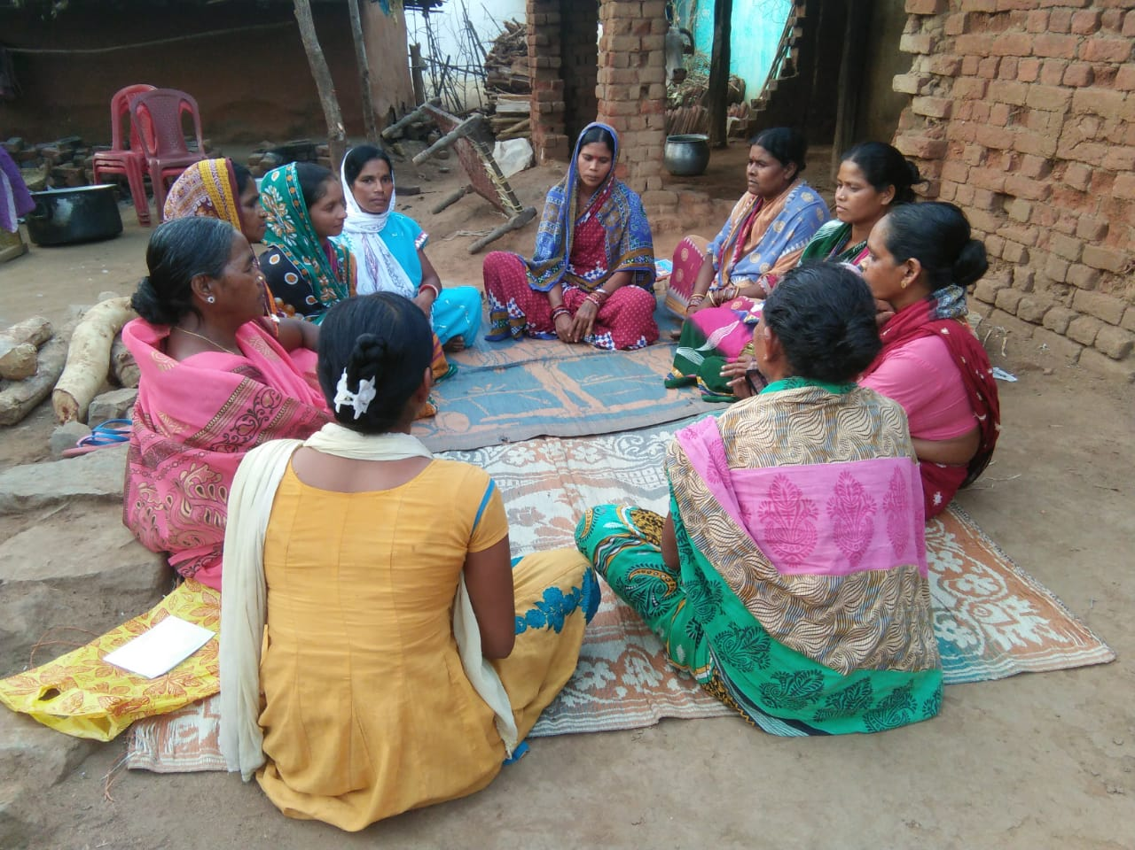

Kansapalla is village with a population of 1516 people and 336 households located at the foothill of Gandhamardan hills of western ghat in Belpada Block of Bolangir district of Odisha. The literacy rate is 63% incase male & 48% incase female. Scheduled tribes, schedule caste and other backward caste families reside in the village. They speak in oria and local koshali language.Electricity is connected to village since last ten years. Kuccha road is connected village. Agriculture, animalhusbandry, NTFP collection &marketing, migration and small trading are the main occupation of the families. There has been a historical change in the thinking, attitude and personalities of the women in the village since last few years. The women are no longer tolerating being beaten by their husband. The self confidence has increased due to their growth in entrepreneurship and no longer dependency on traditional money lenders. The increased income is helping them to meet their family expenses and not to migrate further in a hazardous condition. This is possible due to the formation and effective management of self help group in village.
Mr Premananda Sahu, Community worker of NGO , SANJOGA shared the concept women self help group under anchor NGO scheme and helped them to form a group. Ten SC women members under leadership of Mrs Santoshini Hial & Mrs Pankajini Barik formed the group named DUMER TALEN SHG on 17th February 2014. Initially they started monthly saving of fifty rupees. The members opened a SB account with local Utkal Grameen Bank,Gambari Branch in name of SHG. They are guided to increase the saving amount thinking it will help them to start small business activities in near future. This group saving will reduce their dependence from the clutches of money lender (sahukar) for festival, health and consumption loans. Initially the community worker supplied a register, a set of rubber stamp, a display board free of cost to SHG. The goup members regular conducted the meeting twice in a month. The secretary and president of the SHG are changed once in every two year. Besides group saving, they are discussing the programmes related to health, education, mid meal and other development programmes being implemented in their village and possible participation of them. Till date there is no internal difference among the members in managing the affairs of SHG. Their active participation in grama shabha each year speaks really their strength.
The members of SHG take loans from it for the purpose of consumption, small business, meeting urgent needs and invest in agriculture. The rate of interest is generally charged 3-5 % monthly from members. Because of their regular deposit and proper documentation in group, they have been able to mobilize a credit of twelve thousand rupees during August 2014 from UGB, Gambari branch and on lend to its members for invest in both paddy ,cotton, pulses cultivation, goatry and vegetable business of their own. The loan amount helped them to purchase of seed, inputs from local dealer directly. After successful repayment of loan within one year period the second loan was sanctioned fifty thousand to group to expand their business. The profit earned from this was used in expenditure for home. Similarly for third time the loan was sanctioned eighty thousand to group being realizing their investment need and to expand business activity on September 2016.Through this loan the members started diversified business like grocery shop, Vegetable vending and other agricultural activities. They able earn a better income of 2000 to 3000 per month. Within a period of one year the group repaid the loan amount and a took a new loan of one lac twenty thousand from same bank to run their business .The prompt repayment and exposure of group members apprised the bank officials from time to time. The SHG members were trained through a number of trainings organized NGO and other institutions. Their husbands now joined with them to expand their continuing entrepreneurial activities. Now the repayment of loan to bank is on right schedule and group has a corpus of 65,000/- within a period of four years.
The group has a plan to take land on lease and start cultivation of maize from kharif 2018 as group enterprise besides their individual business.
The concept of micro finance is closely associated with that of micro enterprise. However, in this village there is a huge scope of investment in the trading of farm products like paddy, cotton, pulses and the return is also fairly good. The SHGs have shown no interest in starting a micro enterprise like ‘seeds and fertilizers trading’ .In any case there appears to be no need for the same, because even otherwise they are getting good profits. Moreover, the necessary accompanying infrastructure likes storage facility for ‘farm inputs’ is not available. Small businesses like keeping goats, chicken etc are being undertaken, in a small scale.
UGB has an arrangement with the insurance companies to provide insurance to the SHG members under PMJDY. Members have not as yet taken advantage of that, but are planning to do so very soon.

Socio-Economic Scenario after SHG Formation

SHG members now there is no more need to go to the money lenders for borrowing money in time of need. The SHGs are coming to their rescue. Initially, the male members of the family controlled the family income, but now, it is the women who are holding the key. Women of the family are now able to offer financial help to make investments in agriculture by taking loans from the SHGs. Due to this qualitative change in the contribution of women to the family, the acceptability of women by the male members of the village in terms of the formers’ freedom to sit with them in village meetings (which was absent before) and they now have a role in the decision making on issues within and outside the family. The male members of the village say that SHGs have been a boon for the whole village. When asked about the changing role of women, the male members say that their attitude towards the women has undergone a change. They are of the view that women also should be allowed to speak as everybody has the right to do so.

Wife battering is no more taking place. The unity and the rejuvenated confidence of women have helped put a stop to this menace in their village. When asked if any woman’s husbands come drunk and beat them what would they do? In a single voice all the women of the SHGs said that they would deal with the offender summarily and effectively.

The equation between male and female has been redefined. It is now a cooperative relationship instead of one dominating the other. This is conspicuous as the male members are also invited to the SHG’s meetings and the females given the scope to sit-in at village meetings. During the selling of agricultural products by the SHGs to traders the male members often help to ensure that traders do not cheat the SHGs.

The level of awareness among the women has certainly gone up. Due to the economic independence, group affiliation, exposure owing to their dealing with outside people, etc, they have become more assertive in demanding their rights. Given the education level of the people in the village, which is very low, this kind of transformation in the social status of women and change in the attitude of males towards them is certainly no mean achievement.
So proudly the women members speaks, we are able to stand with our ownfeet due to Self help Group programme financed by local Utkal grameen bank,Gambari branch under SHG Bank linkage programme supported by NABARD . Collective Strength is our progress.

